Service of Word & Table

at

Epworth Chapel on the Green
6110 W. Northview Street, Boise, Idaho 83704
208-336-3951
www.epworthchapelonthegreen.org

The Rev. John Crow, Rector and Pastor
208-501-4037

April 28, 2024, 10:00 a.m.

Fifth Sunday of Easter

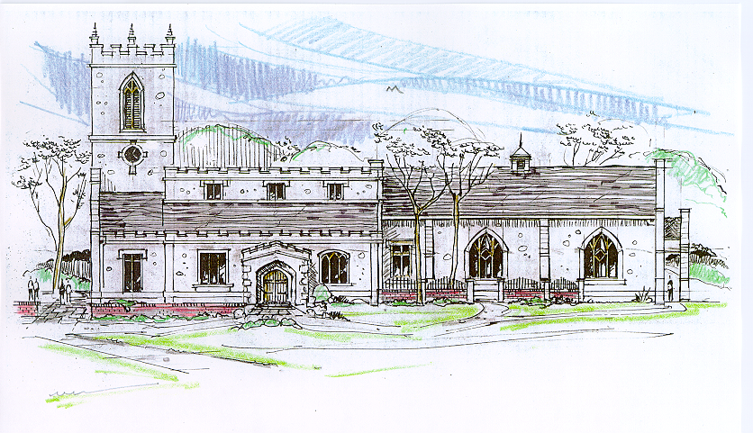
Then the angel spoke to the women, “Don’t be afraid!” He said.
“I know you are looking for Jesus, who was crucified. He isn’t here!
He has been raised from the dead, just as he said would happen. “
Matthew 28:5-6, (NLT)
_______________________________________________________
“Through the deep current of the historical church we will collaboratively serve and reach the lost in order to make disciples who love Jesus.”
_____________________________________________________________
This service will be live streamed, and in the course of that any or all persons who attend may be filmed. Remaining in the service will constitute your consent to appear in the live-streamed, recorded, and published service

Rector and Pastor: The Rev. John Crow
Cantors: Bryan Vanshur, Shannon Nichols
Readers:
Old Testament: Donna Crow
Psalm: Donna Crow
Epistle: Adam Graham
Acolytes: Stephen Crow, Josiah Crow, Corbin Crosswhite, Jessica Crosswhite
Jr. Acolytes: Asher Crow, Corbin, Jessica, & Lizzie Crosswhite
Usher: Kendra Millar
_______________________________
ACTS OF ENTRANCE
(The people enter and remain in prayer and meditation.)
Entrance canticle (cantors only):
“Returning to his throne above, The friend of sinners cried, “Do this in mem’ry of my love;” He spoke the word, and died.
He tasted death for ev’ry one: The Savior of mankind Out of our sight to heaven gone, But left his pledge behind.” (Returning to His Throne Above, vv. 1-2; Charles Wesley)
Processional Hymn (all standing):
Ye Servants of God (No. 179)
Minister: Blessed be God: Father, Son, and Holy Spirit.
People: And blessed be his kingdom, now and forever.
Minister: Alleluia! Christ is risen.
People: The Lord is risen indeed. Alleluia!

Lord’s Prayer: (found on page 1 in the pew hymnal)
Minister: Let us pray…

The Collect for Purity:
Minister: Almighty God, unto whom all hearts are open, all desires known, and from whom no secrets are hid; cleanse the thoughts of our hearts by the inspiration of your Holy Spirit, that we may perfectly love You, and worthily magnify your holy Name, through Christ our Lord.
All: Amen.

The Gloria Hymn (all standing):
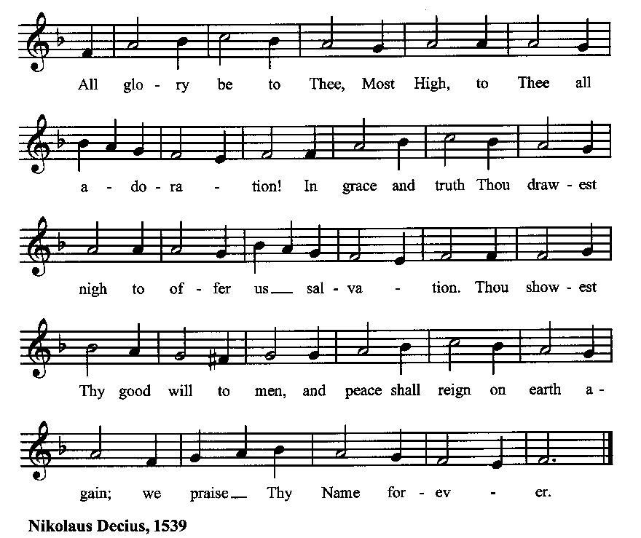

Minister: Holy God, Holy and Mighty, Holy Immortal One,
People: Have mercy upon us.
SERVICE OF THE WORD
Mutual Invocation of the Grace of God for the Service of the Word:
Minister: The Lord be with you.
People: And also with you.
(The people then be seated.)

The Great Commandments (the people sitting):
Minister: Hear what our Lord Jesus Christ says. You shall love the Lord your God with all your heart, and with all your soul, and with all your mind. This is the first and great commandment. And the second is like unto it: You shall love your neighbor as yourself. On these two commandments hang all the Law and the Prophets.

The Kyrie (the people sitting):
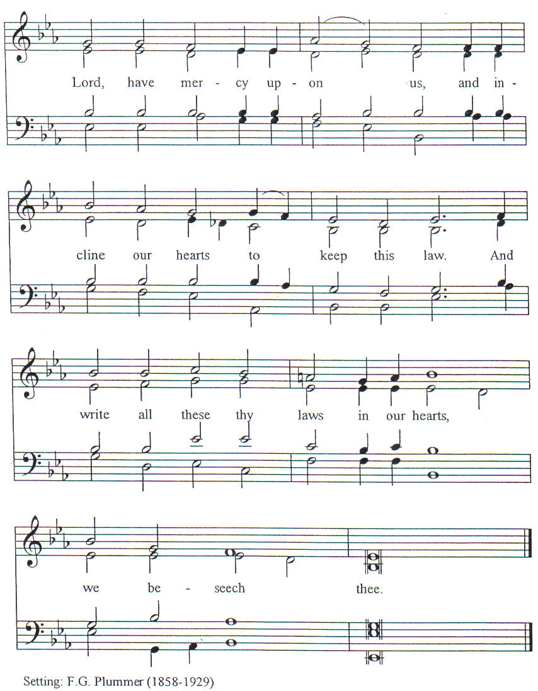

New Testament Lesson (the people sitting):
Reader: The New Testament reading is written in the eighth chapter of the Acts of the Apostles, beginning at verse 26:
26 But an angel of the Lord said to Philip, “Rise and go toward the south to the road that goes down from Jerusalem to Gaza.” This is a desert road.
27 And he rose and went. And behold, an Ethiopian, a eunuch, a minister of the Can′dace, queen of the Ethiopians, in charge of all her treasure, had come to Jerusalem to worship
28 and was returning; seated in his chariot, he was reading the prophet Isaiah.
29 And the Spirit said to Philip, “Go up and join this chariot.”
30 So Philip ran to him, and heard him reading Isaiah the prophet, and asked, “Do you understand what you are reading?”
31 And he said, “How can I, unless some one guides me?” And he invited Philip to come up and sit with him.
32 Now the passage of the scripture which he was reading was this: “As a sheep led to the slaughter or a lamb before its shearer is dumb, so he opens not his mouth.
33 In his humiliation justice was denied him. Who can describe his generation? For his life is taken up from the earth.”
34 And the eunuch said to Philip, “About whom, pray, does the prophet say this, about himself or about some one else?”
35 Then Philip opened his mouth, and beginning with this scripture he told him the good news of Jesus.
36 And as they went along the road they came to some water, and the eunuch said, “See, here is water! What is to prevent my being baptized?
37 [And Philip said, “If you believe with all your heart, you may.” And he replied, “I believe that Jesus Christ is the Son of God.”] *
38 And he commanded the chariot to stop, and they both went down into the water, Philip and the eunuch, and he baptized him.
39 And when they came up out of the water, the Spirit of the Lord caught up Philip; and the eunuch saw him no more, and went on his way rejoicing.
40 But Philip was found at Azo′tus, and passing on he preached the gospel to all the towns till he came to Caesare′a. (RSV)
Reader: The Word of the Lord.
People: Thanks be to God.
*Many ancient manuscripts don’t include v. 37
The Psalm: (The people sit for the responsive reading, by half-verse, Psalm 100, a song of praise for God’s goodness.)
Reader: The Psalm is chapter 100, beginning at verse 1:
Reader: 1 Be joyful in the Lord, all you lands;
People: serve the Lord with gladness and come before his presence with a song.
Reader: 2 Know this: The Lord himself is God;
People: he himself has made us, and we are his; we are his people and the sheep of his pasture.
Reader: 3 Enter his gates with thanksgiving; go into his courts with praise
People: give thanks to him and call upon his Name.
Reader: 4 For the Lord is good; his mercy is everlasting;
People: and his faithfulness endures from age to age.
Gloria Patri (the people sitting)
Reader: Glory be to the Father, and to the Son, and to the Holy Spirit;
People: As it was in the beginning, is now and ever shall be, world without end. Amen.
Collect for the Fifth Sunday of Easter:
Minister: Almighty God, whom truly to know is everlasting life: Grant us so perfectly to know your Son Jesus Christ to be the way, the truth, and the life, that we may steadfastly follow his steps in the way that leads to eternal life; through Jesus Christ your Son our Lord, who lives and reigns with you, in the unity of the Holy Spirit, one God, for ever and ever.
All: Amen.

The Epistle (the people sitting):
Reader: The epistle lesson is written in the third chapter of the First letter of John, beginning at verse 11:
- For this is the message which you have heard from the beginning, that we should love one another,
- and not be like Cain who was of the evil one and murdered his brother. And why did he murder him? Because his own deeds were evil and his brother’s righteous.
- Do not wonder, brethren, that the world hates you.
- We know that we have passed out of death into life, because we love the brethren. He who does not love abides in death.
- Any one who hates his brother is a murderer, and you know that no murderer has eternal life abiding in him.
- By this we know love, that he laid down his life for us; and we ought to lay down our lives for the brethren.
- But if any one has the world’s goods and sees his brother in need, yet closes his heart against him, how does God’s love abide in him?
- Little children, let us not love in word or speech but in deed and in truth.
- By this we shall know that we are of the truth, and reassure our hearts before him
- whenever our hearts condemn us; for God is greater than our hearts, and he knows everything.
- Beloved, if our hearts do not condemn us, we have confidence before God;
- and we receive from him whatever we ask, because we keep his commandments and do what pleases him.
- And this is his commandment, that we should believe in the name of his Son Jesus Christ and love one another, just as he has commanded us.
- All who keep his commandments abide in him, and he in them. And by this we know that he abides in us, by the Spirit which he has given us. (RSV)
Reader: Here ends the Epistle.
People: Thanks be to God.
Sequence Hymn (all standing, and turning toward the Gospel reading):
Wondrous Sight for Men and Angels, vv. 1-2 (No. 251)
The Gospel:
Minister: The holy Gospel is written in the fourteenth chapter of the Gospel according to John, beginning at verse 15:
Minister:
- “If you love me, you will keep my commandments.
- And I will pray the Father, and he will give you another Counselor, to be with you for ever,
- even the Spirit of truth, whom the world cannot receive, because it neither sees him nor knows him; you know him, for he dwells with you, and will be in you.
- “I will not leave you desolate; I will come to you.
- Yet a little while, and the world will see me no more, but you will see me; because I live, you will live also.
- In that day you will know that I am in my Father, and you in me, and I in you.
- He who has my commandments and keeps them, he it is who loves me; and he who loves me will be loved by my Father, and I will love him and manifest myself to him.” (RSV)
Minister: Alleluia! The Gospel of the Lord.
People: Praise to You, Lord Christ. Alleluia!
Sequence Hymn (the people standing):
Wondrous Sight for Men and Angels, vv. 3-4 (No. 251)
[Elementary age children may exit for Children's Worship in the Parish Hall.
They will return to the service at the Passing of the Peace.]
Minister: Grace be unto you, and peace, from our Lord Jesus Christ.
All: Amen. (The people then be seated.)
The Sermon
Minister: In the name of the Father, the Son and the Holy Spirit.

Silence, for review of the sermon, and for meditative prayer

SERVICE OF THE TABLE: THE GREAT THANKSGIVING
The Nicene Creed (all standing): (found on page II in the pew hymnal)
Minister: Let us confess our faith, saying…

Minister: (The people sitting) Yours, O Lord, is the greatness, the power, the glory, the victory, and the majesty. For everything in heaven and on earth is yours. Yours, O Lord, is the kingdom, and You are exalted as head over all. (I Chronicles 29:11)
Offertory:
Offering Hymn (the people standing):
Oft I in My Heart Have Said (No. 258)
Minister: All things come from You, O Lord,
People: And of your own have we given You.
The Prayers of the People (the people kneeling or sitting):
Minister: Let us pray for the Church and the world. For the unity of the Church throughout the world, that we might faithfully preach the Gospel to the ends of the earth, let us pray to the Lord:
People: Lord, hear our prayer.
Minister: For the persecuted church, and for its persecutors, that You would turn their hearts, let us pray to the Lord:
People: Lord, hear our prayer.
Minister: For our President and all who govern and hold authority in our nation and in the world, let us pray to the Lord:
People: Lord, hear our prayer.
Minister: For the good earth which You have given us, and for the wisdom and will to conserve it, let us pray to the Lord:
People: Lord, hear our prayer.
Minister: For all ministers of your Gospel, that they might faithfully preach your Word, administer your sacraments, and care for your people, let us pray to the Lord:
People: Lord, hear our prayer.
Minister: For the peace of the world, that a spirit of respect and forbearance may grow among all nations and peoples, let us pray to the Lord:
People: Lord, hear our prayer.
Minister: For all those who do not yet believe, and for those who have lost their faith, that in due time we may all stand reconciled before You, let us pray to the Lord:
People: Lord, hear our prayer.
Minister: For the poor and the oppressed, prisoners and captives, the unemployed, and all who are in need or trouble, let us pray to the Lord:
People: Lord, hear our prayer.
Minister: For our enemies and all who wish us harm, and for all whom we have injured or offended, let us pray to the Lord:
People: Lord, hear our prayer.
Minister: For this congregation, that we might show forth your glory in all that we do; and for those who have commended themselves to our prayers, including these: _____________:
[Nation: Timor-Leste
Denomination: Church of the Rock
Congregation: Parkview Nazarene Church in North Platte, NE, and the Rev. James Tippett
Ministry: Crew
Parishioners: Those living on Larch Street],
Grant that all of these may be delivered from anxiety, and live in joy, peace, and health.
(Please add your own intentions, either silently or aloud.)
Minister: Let us pray to the Lord:
People: Lord, hear our prayer.
Minister: We bless your holy Name for the thanksgivings of your people, including these: _________; for those in every generation in whom Christ has been honored; Give us grace to follow their good examples, that with them we may be partakers of your heavenly kingdom.
(Please add your intentions, either silently or aloud.)
Minister: Let us pray to the Lord:
People: Lord, hear our prayer
Collect:
Minister: O God our King, by the resurrection of your Son Jesus Christ on the first day of the week, You conquered sin, put death to flight, and gave us the hope of everlasting life: Redeem all our days by this victory; forgive our sins, banish our fears, make us bold to praise You and to do your will; and steel us to wait for the consummation of your kingdom on the last great day; through Jesus Christ our Lord.
All: Amen. (The people sit.)
Preparation for Holy Communion (the people sitting):
Minister: The Lord’s Supper was ordained by God to be a means of conveying grace according to the need of each person. Those for whom it was ordained are all those who know and feel that they want the grace of God, to restrain them from sin, or to forgive their sins, or to assure them of pardon, or to renew their souls in the image of God, or to enter into the holy presence of God in communion with him. No preparation is indispensably necessary, other than a desire to receive the grace God pleases to give. No fitness or church membership is required at the time of communicating, other than a sense of our state, of our utter sinfulness and helplessness apart from Christ. Therefore, if you want such grace as God pleases to give to you, draw near with faith, and as you prepare to receive this holy sacrament to your comfort and strength, make your sincere confession to Almighty God, kneeling if you wish and are able, or otherwise sitting.

The Prayer of Confession, Petition and Thanksgiving:
(The minister kneels, and the people kneel or sit.)
Minister: Let us pray together:
All: Almighty God, Father of our Lord Jesus Christ, Maker of all things, Judge of all persons: We have erred and strayed from your ways like lost sheep. We have followed too much the devices and desires of our own hearts. You have shown us the way of life through your Son, Jesus Christ. Where there is sin or falling short of your will in our lives, or any spiritual pride, carelessness or presumption on our part, or any failure to see or know your good and righteous will, we earnestly repent and are heartily sorry for our misdoings. Forgive us all that is past, grant that we may ever serve and please You in newness of life, and accept our thanksgiving for the wondrous grace and forgiveness You extend to us, to the honor and glory of your Name, through Jesus Christ our Lord. Amen.

The Agnus Dei (the people kneeling or sitting, singing):
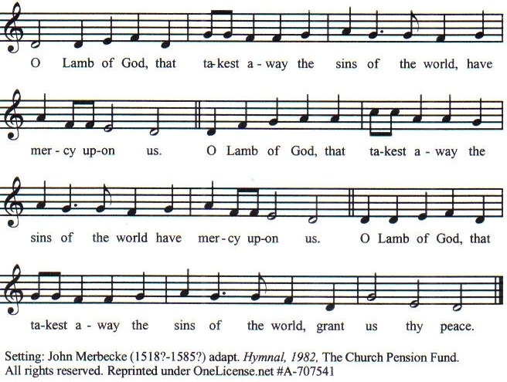

Prayer for Absolution (the people kneeling or sitting):
Minister: Almighty God, our heavenly Father, who of your great mercy has promised forgiveness of sins to all those who with hearty repentance and true faith turn unto You; Have mercy upon us; pardon and deliver us from all our sins, confirm and strengthen us in all goodness, and bring us to everlasting life, through Jesus Christ our Lord.
All: Amen.

The Comforting Words of Forgiveness (the people sitting):
Minister: Hear what comforting words our Savior Christ says to all who truly turn to him: Come to me, all you who are weary and carry heavy burdens, and I will give you rest. God so loved the world that he gave his only Son, so that everyone who believes in him will not perish but have eternal life. Hear also what St. Paul says: Christ Jesus came into the world to save sinners. Hear also what St. John says: If anyone sins, we have an Advocate with the Father, Jesus Christ the righteous: and he is the atonement for our sins.

The Passing of the Peace:
Minister: The peace of the Lord be always with you.
People: And also with you.
Minister: As the peace of Christ has been extended to you, extend the peace of the Lord to one another, and greet one another in the name of the Lord. (The people rise and remain standing.)
(The people greet those near to them, saying, “The peace of the Lord be with you,” or, “Peace be with you,” or simply, “Peace.” They respond to one another, “And also with you,” or simply, “Peace”.)
Hymn of Entry Into the Heavenly Worship (the people standing):
Arise, My Soul, Arise (No. 175)
Preparation for the Table:
(Minister: I wash my hands in innocence, and go about your altar, O LORD, proclaiming aloud your praise and telling of all your wonderful deeds). [Psalm 26:6-7, NIV]
The Sursum Corda (all standing):
Minister: The Lord be with you.
People: And also with you.
Minister: Lift up your hearts.
People: We lift them up unto the Lord.
Minister: Let us give thanks unto our Lord God.
People: It is meet and right so to do.
The Salutation:
Minister: It is very meet, right, and our gladsome duty, that we should at all times, and in all places, give thanks unto You, O Lord, Holy Father, Almighty, Everlasting God.
The Preface:
Minister: But chiefly we are bound to praise You for the glorious resurrection of your Son Jesus Christ our Lord; for he is the very Paschal Lamb, who was sacrificed for us, and he has taken away the sin of the world. By his death He has destroyed death, and by his rising to life again He has won for us everlasting life.
Minister: Therefore, with Angels and Archangels and with all the company of heaven, we laud and magnify your glorious Name, evermore praising You, and saying,

The Sanctus:
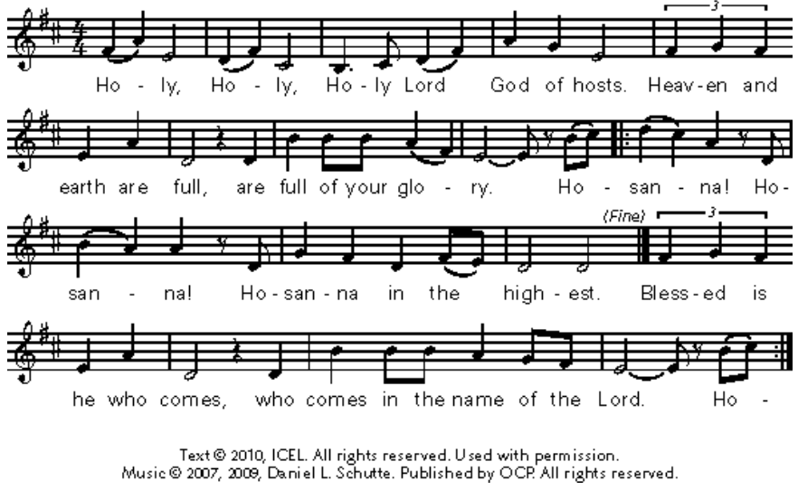
The Prayer of Humble Access and for Cleansing
(the people kneeling or sitting):
Minister: Let us pray together:
All: We do not presume to come to this your table, O merciful Lord, trusting in our own righteousness, but in your many and great mercies. We are not worthy so much as to gather up the crumbs under your table. But You are the same Lord, whose nature is always to have mercy: Grant us, therefore, gracious Lord, so to experience the spiritual presence of your dear Son Jesus Christ at this your table, that we may be made clean by his body and blood, and that we may evermore dwell in him, and he in us. Deliver us, gracious Lord, from the presumption of coming to this table for solace for ourselves only, and not for strength to serve You and others. Deliver us, gracious Lord, from the presumption of coming to this table for pardon of our sins only, and not for transformation of our lives in your holiness. Amen.
Epiclesis Prayer (the people kneeling or sitting):
Minister: Holy and gracious Father, in your infinite love You made us for yourself; and, when we had fallen into sin and become subject to evil and death, You sent Jesus Christ, your only and eternal Son, to share our human nature, to live and die as one of us, to reconcile us to You, the God and Father of all. He stretched out his arms upon the cross and offered himself, in obedience to your will, a perfect sacrifice for the sins of the whole world. Recalling now his death, resurrection, and ascension, we offer You these gifts. Sanctify them by your Holy Spirit to be for us the Body and Blood of your Son, the holy food and drink of new and unending life in him. Sanctify us also, that we may faithfully receive this holy Sacrament, and serve You in unity, constancy, and peace; and at the last day bring us with all your saints into the joy of your eternal kingdom. We ask this through Jesus Christ, your Son, our Lord; through him, and with him, and in him, in the unity of the Holy Spirit, all honor and glory are yours, O Father Almighty, now and forever.
All: Amen.
The Words of Institution (the people kneeling or sitting):
Minister: Our Lord Jesus Christ, on the night that he was betrayed took bread; and when he had given thanks, he broke it, and gave it to his disciples, saying, Take, eat; this is my Body which is given for you: Do this in remembrance of me.
Likewise, after supper, he took the cup; and when he had given thanks, he gave it to them, saying, Drink this, all of you; for this is my blood of the New Testament, which is shed for you, and for many, for the remission of sins: Do this, as often as you shall drink it, in remembrance of me.
All: Amen.
Minister: Therefore, we proclaim: Alleluia! Christ is risen.
People: The Lord is risen indeed. Alleluia.
The Fraction:
Minister: Alleluia! Christ our passover is sacrificed for us.
People: Therefore let us keep the feast. Alleluia.

Fraction Anthem (the people kneeling or sitting, singing):
(The cantor sings the first line, and then all sing the other lines.)
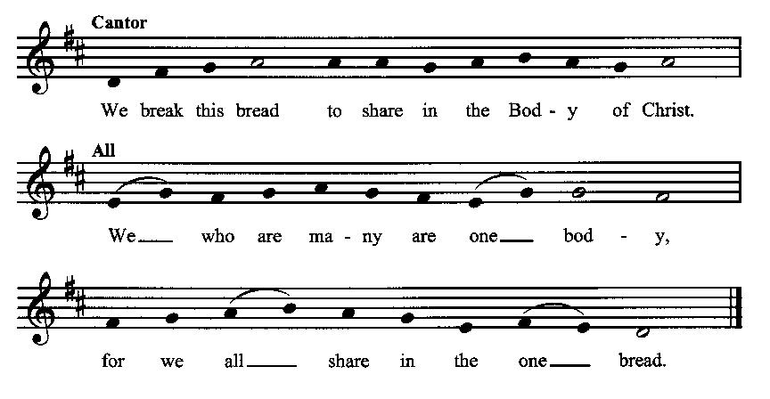
Minister: The gifts of God for the people of God. Take them in remembrance that Christ died for you and rose again, and feed on him in your hearts by faith with thanksgiving.
Communion Hymn (cantors only, the people kneeling or sitting):
“His sacramental pledge we take, Nor will we let it go; Till in the clouds our Lord comes back, We thus his death will show.
Come quickly, Lord, for whom we mourn, And comfort all that grieve; Prepare the bride, and then return, And to Thyself receive.
Now to thy glorious kingdom come; (Thou hast a token giv’n) And while thy arms receive us home, Recall thy pledge in heav’n.” (Returning to His Throne Above, vv. 3-5; Charles Wesley)
The Communion, open to all: (After the minister(s) and acolyte(s) are served, the people come forward to receive, as space is available. The people kneel if they are able, or STAND in accord with the practice of the ancient church during Easter, symbolic of being raised up with Christ in his victory. Communion by intincture: The people receive the Bread in their open hands, continue to hold it, then dip the Bread in the cup, and then consume.) They return to their seats via the side aisles.
Renewal of the Mutual Invocation of God’s Grace for the Eucharist:
Minister: The Lord be with you.
People: And also with you.
The Prayer of Thanksgiving and Living Sacrifice:
(The minister kneeling, the people kneeling or sitting):
Minister: Let us pray together:
All: O Lord and Heavenly Father, we heartily thank You because You feed us, in these holy mysteries, with the spiritual food of the most precious Body and Blood of your Son our Savior Jesus Christ; because by this You assure us of your favor and goodness toward us; because we are living members of the body of your Son and heirs of your eternal kingdom. We ask You to accept this our sacrifice of praise and thanksgiving, and to grant that by the merits and death of your Son Jesus Christ and through faith in him, we and all your whole Church may obtain all of the benefits of his passion. And here we offer and present unto You, O Lord, ourselves, our souls and bodies, to be a reasonable, holy, and living sacrifice unto You; humbly asking You that we may be filled with your grace and heavenly benediction; through Jesus Christ our Lord; by whom, and with whom, in the Unity of the Holy Spirit, all honor and glory be unto You, O Father Almighty, world without end. AMEN.

The Gloria Prayer of Praise and Thanksgiving (all standing):
Minister: Let us pray together:
All: Glory be to God on high, and on earth peace, good-will toward all people. We praise You, we bless You, we worship You, we glorify You, we give thanks to You for your great glory, O Lord God, heavenly King, God the Father Almighty. For You only are the Holy One, You only are the Lord, You only, O Christ, with the Holy Spirit, are most high in the glory of God the Father. Amen.
ACTS OF DISMISSAL
Recessional Hymn (all standing, singing):
Come, Ye Faithful, Raise the Strain (No. 164)
The Prayer of Benediction:
Minister: May the power of God that raised Jesus from the dead raise us up with him also and give life to our mortal bodies; and may the blessing of God Almighty, the Father, the Son, and the Holy Spirit, be among you, and remain with you always.
All: Amen.
Minister: Let us go forth in the power of the risen Christ.
People: Thanks be to God. Alleluia. Alleluia.
(The people then be seated.)
Greetings and Announcements
Postlude:
(The people sit and remain quiet until the candles are extinguished and the organ raises its voice.)

_________________________________________________________
Based on, and freely adapted from,
John Wesley’s Order for the Administration of the Lord’s Supper,
the 1662 and 1979 editions of The Book of Common Prayer, and
Common Worship: Services and Prayers for the Church of England
_____________________________________________________________

Scripture lessons for May 5 (Easter 6):
Acts 11:19-30; Psalm 33:1-8; I John 3:11-24; John 14:15-21

Parish Prayer for This Week and Next Sunday
Those living on Leisure Drive
__________________________________________

Parish Notices

Today: Congregational Vote
Immediately following today’s service we will be holding a vote open to all current members of Epworth. It will be a very brief vote to ratify the Board’s decision to officially join the Free Methodist Church.

Tea & Tomes
Our next book will be The Abolition of Man by C. S. Lewis. The book critiques the idea of moral relativism and points out the consequences for society of denying objective values. These consequences are far greater than you might think. Even though the book is 80 years old, it has proven prophetic as we are now living in the world it warned of. Stan & Donna Crow will be hosting the discussion on Saturday, June 1st, at 2 pm.

Coming Soon: Pentecost Potluck!
Coming up this year on May 19, we will celebrate "The Birthday of the Church", when the Holy Spirit descended on the apostles, as recorded in Acts 2, which falls 50 days after Easter. All are encouraged to wear RED, as we celebrate one of the major festivals of the Christian year with our usual Pentecost Potluck. Epworth will furnish Ham, rolls, drinks and our traditional Pentecost Cake. Please plan to bring either a salad or a side dish to round out the menu. A sign-up sheet will be made available starting next Sunday on May 5. There will also be games for the children.

Coming Events at Epworth

Today, 10:00 am Word & Table Service
Today, 11:30 am Fellowship
Today, 11:40 am Afterword (moderated discussion)
Thursday, 7:00 pm Evening Prayers
Sunday, 12 May Ascension Sunday
Sunday, 19 May Pentecost Sunday
Sunday, 26 May Trinity Sunday

May Birthdays & Anniversaries

02 – Chris Blanchard
04 – Sergei Crow
28 – Lorrie Walker
31 – Suzan Allmark

Sermon Notes

Epworth Church Office Email
epworthchapel.office@gmail.com
All correspondence for the office should be sent to this email address.

Pastor Crow Contact Information
Healing prayer is provided every week upon request
Rev. John Crow, Interim Rector and Pastor
208-501-4037
jdowningcrow@hotmail.com

