Service of Word & Table

at

Epworth Chapel on the Green
6110 W. Northview Street, Boise, Idaho 83704
208-336-3951
www.epworthchapelonthegreen.org

The Rev. John Crow, Rector and Pastor
208-501-4037

April 21, 2024, 10:00 a.m.

Fourth Sunday of Easter

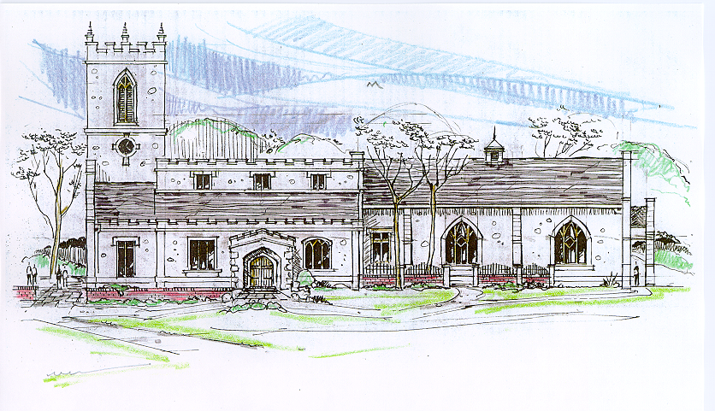
Then the angel spoke to the women, “Don’t be afraid!” He said.
“I know you are looking for Jesus, who was crucified. He isn’t here!
He has been raised from the dead, just as he said would happen. “
Matthew 28:5-6, (NLT)
_______________________________________________________
“Through the deep current of the historical church we will collaboratively serve and reach the lost in order to make disciples who love Jesus.”
_____________________________________________________________
This service will be live streamed, and in the course of that any or all persons who attend may be filmed. Remaining in the service will constitute your consent to appear in the live-streamed, recorded, and published service

Rector and Pastor: The Rev. John Crow
Cantors: Bryan Vanshur, Shannon Nichols
Readers:
Old Testament: Stan Crow
Psalm: Stan Crow
Epistle: Chris Blanchard
Acolytes: Stephen Crow, Josiah Crow, Corbin Crosswhite, Jessica Crosswhite
Jr. Acolytes: Asher Crow, Corbin, Jessica, & Lizzie Crosswhite
Usher: Kendra Millar
_______________________________
ACTS OF ENTRANCE
(The people enter and remain in prayer and meditation.)
Entrance canticle (cantors only):
“Good Christians all, rejoice and sing! Now is the triumph of our King! To all the world glad news we bring: Alleluia! Alleluia! Alleluia!
The Lord of life is risen today! Bring flowers of song, bedeck the way; Let ev’ry tongue rejoice and say: Alleluia! Alleluia! Alleluia!” (Good Christians All, Rejoice and Sing, vv. 1-2; Cyril Alington, alt.)
Processional Hymn (all standing):
Now the Green Blade Riseth (No. 189)
Minister: Blessed be God: Father, Son, and Holy Spirit.
People: And blessed be his kingdom, now and forever.
Minister: Alleluia! Christ is risen.
People: The Lord is risen indeed. Alleluia!

Lord’s Prayer: (found on page 1 in the pew hymnal)
Minister: Let us pray…

The Collect for Purity:
Minister: Almighty God, unto whom all hearts are open, all desires known, and from whom no secrets are hid; cleanse the thoughts of our hearts by the inspiration of your Holy Spirit, that we may perfectly love You, and worthily magnify your holy Name, through Christ our Lord.
All: Amen.

The Gloria Hymn (all standing):
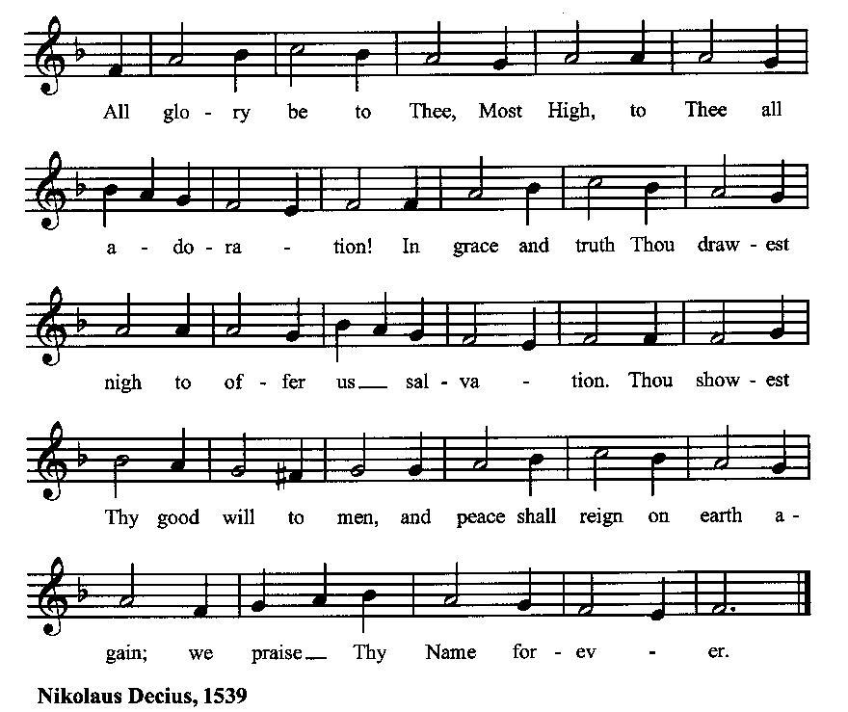

Minister: Holy God, Holy and Mighty, Holy Immortal One,
People: Have mercy upon us.
SERVICE OF THE WORD
Mutual Invocation of the Grace of God for the Service of the Word:
Minister: The Lord be with you.
People: And also with you.
(The people then be seated.)

The Great Commandments (the people sitting):
Minister: Hear what our Lord Jesus Christ says. You shall love the Lord your God with all your heart, and with all your soul, and with all your mind. This is the first and great commandment. And the second is like unto it: You shall love your neighbor as yourself. On these two commandments hang all the Law and the Prophets.

The Kyrie (the people sitting):
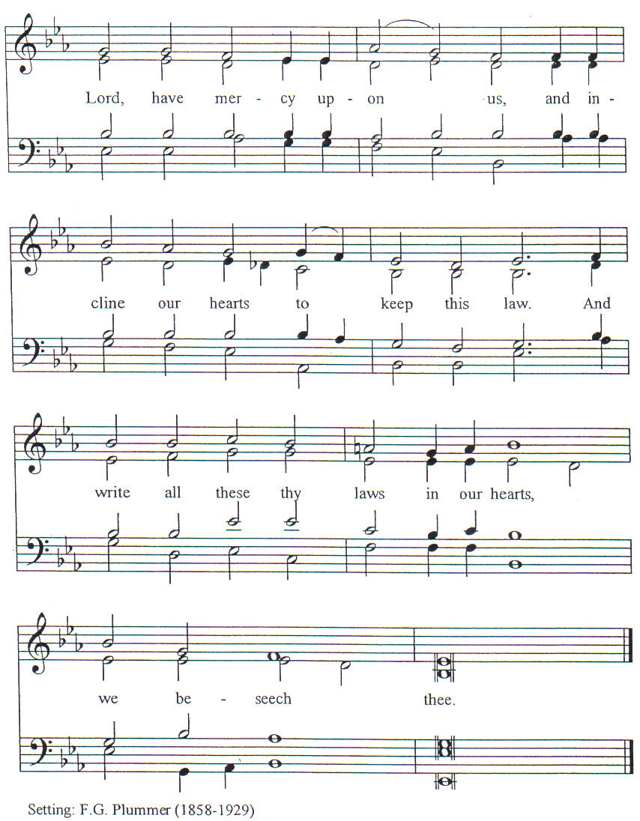

New Testament Lesson (the people sitting):
Reader: The New Testament reading is written in the fourth chapter of the Acts of the Apostles, beginning at verse 23:
23 When they were released they went to their friends and reported what the chief priests and the elders had said to them.
24 And when they heard it, they lifted their voices together to God and said, “Sovereign Lord, who didst make the heaven and the earth and the sea and everything in them,
25 who by the mouth of our father David, thy servant, didst say by the Holy Spirit, ‘Why did the Gentiles rage, and the peoples imagine vain things?
26 The kings of the earth set themselves in array, and the rulers were gathered together, against the Lord and against his Anointed’—
27 for truly in this city there were gathered together against thy holy servant Jesus, whom thou didst anoint, both Herod and Pontius Pilate, with the Gentiles and the peoples of Israel,
28 to do whatever thy hand and thy plan had predestined to take place.
29 And now, Lord, look upon their threats, and grant to thy servants to speak thy word with all boldness,
30 while thou stretchest out thy hand to heal, and signs and wonders are performed through the name of thy holy servant Jesus.”
31 And when they had prayed, the place in which they were gathered together was shaken; and they were all filled with the Holy Spirit and spoke the word of God with boldness. (RSV)
Reader: The Word of the Lord.
People: Thanks be to God.
The Psalm: (The people sit for the responsive reading, by half-verse, Psalm 100, a song of praise for God’s goodness.)
Reader: The Psalm is chapter 100, beginning at verse 1:
Reader: 1 Be joyful in the Lord, all you lands;
People: serve the Lord with gladness and come before his presence with a song.
Reader: 2 Know this: The Lord himself is God;
People: he himself has made us, and we are his; we are his people and the sheep of his pasture.
Reader: 3 Enter his gates with thanksgiving; go into his courts with praise
People: give thanks to him and call upon his Name.
Reader: 4 For the Lord is good; his mercy is everlasting;
People: and his faithfulness endures from age to age.
Gloria Patri (the people sitting)
Reader: Glory be to the Father, and to the Son, and to the Holy Spirit;
People: As it was in the beginning, is now and ever shall be, world without end. Amen.
Collect for the Fourth Sunday of Easter:
Minister: O God, whose Son Jesus is the good shepherd of your people; Grant that when we hear his voice we may know him who calls us each by name, and follow where he leads; who, with you and the Holy Spirit, lives and reigns, one God, for ever and ever.
All: Amen.

The Epistle (the people sitting):
Reader: The epistle lesson is written in the third chapter of the First letter of John, beginning at verse 1:
- See what love the Father has given us, that we should be called children of God; and so we are. The reason why the world does not know us is that it did not know him.
- Beloved, we are God’s children now; it does not yet appear what we shall be, but we know that when he appears we shall be like him, for we shall see him as he is.
- And every one who thus hopes in him purifies himself as he is pure.
- Every one who commits sin is guilty of lawlessness; sin is lawlessness.
- You know that he appeared to take away sins, and in him there is no sin.
- No one who abides in him sins; no one who sins has either seen him or known him.
- Little children, let no one deceive you. He who does right is righteous, as he is righteous.
- He who commits sin is of the devil; for the devil has sinned from the beginning. The reason the Son of God appeared was to destroy the works of the devil.
- No one born of God commits sin; for God’s nature abides in him, and he cannot sin because he is born of God.
- By this it may be seen who are the children of God, and who are the children of the devil: whoever does not do right is not of God, nor he who does not love his brother. (RSV)
Reader: Here ends the Epistle.
People: Thanks be to God.
Sequence Hymn (all standing, and turning toward the Gospel reading):
Christ, Thou Art Our Glorious King, vv. 1-2 (No. 176)
The Gospel:
Minister: The holy Gospel is written in the tenth chapter of the Gospel according to John, beginning at verse 11:
Minister:
- I am the good shepherd. The good shepherd lays down his life for the sheep.
- He who is a hireling and not a shepherd, whose own the sheep are not, sees the wolf coming and leaves the sheep and flees; and the wolf snatches them and scatters them.
- He flees because he is a hireling and cares nothing for the sheep.
- I am the good shepherd; I know my own and my own know me,
- as the Father knows me and I know the Father; and I lay down my life for the sheep.
- And I have other sheep, that are not of this fold; I must bring them also, and they will heed my voice. So there shall be one flock, one shepherd. (RSV)
Minister: Alleluia! The Gospel of the Lord.
People: Praise to You, Lord Christ. Alleluia!
Sequence Hymn (the people standing):
Christ, Thou Art Our Glorious King, vv. 3 (No. 176)
[Elementary age children may exit for Children's Worship in the Parish Hall.
They will return to the service at the Passing of the Peace.]
Minister: Grace be unto you, and peace, from our Lord Jesus Christ.
All: Amen. (The people then be seated.)
The Sermon
Minister: In the name of the Father, the Son and the Holy Spirit.

Silence, for review of the sermon, and for meditative prayer

SERVICE OF THE TABLE: THE GREAT THANKSGIVING
The Nicene Creed (all standing): (found on page II in the pew hymnal)
Minister: Let us confess our faith, saying…

Minister: (The people sitting) Yours, O Lord, is the greatness, the power, the glory, the victory, and the majesty. For everything in heaven and on earth is yours. Yours, O Lord, is the kingdom, and You are exalted as head over all. (I Chronicles 29:11)
Offertory:
Offering Hymn (the people standing):
For the Life That You Have Given (No. 485)
Minister: All things come from You, O Lord,
People: And of your own have we given You.
The Prayers of the People (the people kneeling or sitting):
Minister: Let us pray for the Church and the world. For the unity of the Church throughout the world, that we might faithfully preach the Gospel to the ends of the earth, let us pray to the Lord:
People: Lord, hear our prayer.
Minister: For the persecuted church, and for its persecutors, that You would turn their hearts, let us pray to the Lord:
People: Lord, hear our prayer.
Minister: For our President and all who govern and hold authority in our nation and in the world, let us pray to the Lord:
People: Lord, hear our prayer.
Minister: For the good earth which You have given us, and for the wisdom and will to conserve it, let us pray to the Lord:
People: Lord, hear our prayer.
Minister: For all ministers of your Gospel, that they might faithfully preach your Word, administer your sacraments, and care for your people, let us pray to the Lord:
People: Lord, hear our prayer.
Minister: For the peace of the world, that a spirit of respect and forbearance may grow among all nations and peoples, let us pray to the Lord:
People: Lord, hear our prayer.
Minister: For all those who do not yet believe, and for those who have lost their faith, that in due time we may all stand reconciled before You, let us pray to the Lord:
People: Lord, hear our prayer.
Minister: For the poor and the oppressed, prisoners and captives, the unemployed, and all who are in need or trouble, let us pray to the Lord:
People: Lord, hear our prayer.
Minister: For our enemies and all who wish us harm, and for all whom we have injured or offended, let us pray to the Lord:
People: Lord, hear our prayer.
Minister: For this congregation, that we might show forth your glory in all that we do; and for those who have commended themselves to our prayers, including these: _____________:
[Nation: Thailand
Denomination: Church of the Nazarene
Congregation: Vale Christian Church in Vale, OR, and the Rev. Paul Karsten
Ministry: Exponential
Parishioners: Those living on Joretta Drive],
Grant that all of these may be delivered from anxiety, and live in joy, peace, and health.
(Please add your own intentions, either silently or aloud.)
Minister: Let us pray to the Lord:
People: Lord, hear our prayer.
Minister: We bless your holy Name for the thanksgivings of your people, including these: _________; for those in every generation in whom Christ has been honored; Give us grace to follow their good examples, that with them we may be partakers of your heavenly kingdom.
(Please add your intentions, either silently or aloud.)
Minister: Let us pray to the Lord:
People: Lord, hear our prayer
Collect:
Minister: O God our King, by the resurrection of your Son Jesus Christ on the first day of the week, You conquered sin, put death to flight, and gave us the hope of everlasting life: Redeem all our days by this victory; forgive our sins, banish our fears, make us bold to praise You and to do your will; and steel us to wait for the consummation of your kingdom on the last great day; through Jesus Christ our Lord.
All: Amen. (The people sit.)
Preparation for Holy Communion (the people sitting):
Minister: The Lord’s Supper was ordained by God to be a means of conveying grace according to the need of each person. Those for whom it was ordained are all those who know and feel that they want the grace of God, to restrain them from sin, or to forgive their sins, or to assure them of pardon, or to renew their souls in the image of God, or to enter into the holy presence of God in communion with him. No preparation is indispensably necessary, other than a desire to receive the grace God pleases to give. No fitness or church membership is required at the time of communicating, other than a sense of our state, of our utter sinfulness and helplessness apart from Christ. Therefore, if you want such grace as God pleases to give to you, draw near with faith, and as you prepare to receive this holy sacrament to your comfort and strength, make your sincere confession to Almighty God, kneeling if you wish and are able, or otherwise sitting.

The Prayer of Confession, Petition and Thanksgiving:
(The minister kneels, and the people kneel or sit.)
Minister: Let us pray together:
All: Almighty God, Father of our Lord Jesus Christ, Maker of all things, Judge of all persons: We have erred and strayed from your ways like lost sheep. We have followed too much the devices and desires of our own hearts. You have shown us the way of life through your Son, Jesus Christ. Where there is sin or falling short of your will in our lives, or any spiritual pride, carelessness or presumption on our part, or any failure to see or know your good and righteous will, we earnestly repent and are heartily sorry for our misdoings. Forgive us all that is past, grant that we may ever serve and please You in newness of life, and accept our thanksgiving for the wondrous grace and forgiveness You extend to us, to the honor and glory of your Name, through Jesus Christ our Lord. Amen.

The Agnus Dei (the people kneeling or sitting, singing):
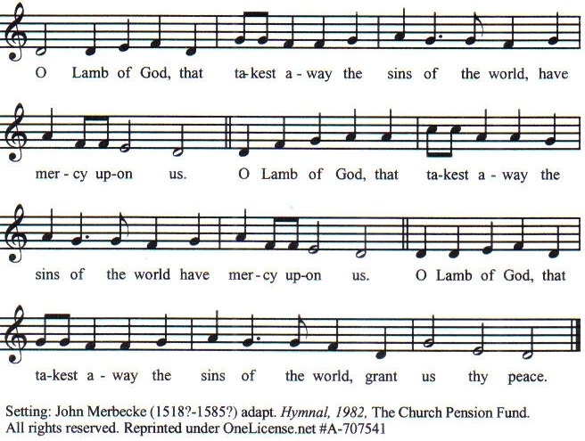

Prayer for Absolution (the people kneeling or sitting):
Minister: Almighty God, our heavenly Father, who of your great mercy has promised forgiveness of sins to all those who with hearty repentance and true faith turn unto You; Have mercy upon us; pardon and deliver us from all our sins, confirm and strengthen us in all goodness, and bring us to everlasting life, through Jesus Christ our Lord.
All: Amen.

The Comforting Words of Forgiveness (the people sitting):
Minister: Hear what comforting words our Savior Christ says to all who truly turn to him: Come to me, all you who are weary and carry heavy burdens, and I will give you rest. God so loved the world that he gave his only Son, so that everyone who believes in him will not perish but have eternal life. Hear also what St. Paul says: Christ Jesus came into the world to save sinners. Hear also what St. John says: If anyone sins, we have an Advocate with the Father, Jesus Christ the righteous: and he is the atonement for our sins.

The Passing of the Peace:
Minister: The peace of the Lord be always with you.
People: And also with you.
Minister: As the peace of Christ has been extended to you, extend the peace of the Lord to one another, and greet one another in the name of the Lord. (The people rise and remain standing.)
(The people greet those near to them, saying, “The peace of the Lord be with you,” or, “Peace be with you,” or simply, “Peace.” They respond to one another, “And also with you,” or simply, “Peace”.)
Hymn of Entry Into the Heavenly Worship (the people standing):
Christ Is Alive (No. 200)
Preparation for the Table:
(Minister: I wash my hands in innocence, and go about your altar, O LORD, proclaiming aloud your praise and telling of all your wonderful deeds). [Psalm 26:6-7, NIV]
The Sursum Corda (all standing):
Minister: The Lord be with you.
People: And also with you.
Minister: Lift up your hearts.
People: We lift them up unto the Lord.
Minister: Let us give thanks unto our Lord God.
People: It is meet and right so to do.
The Salutation:
Minister: It is very meet, right, and our gladsome duty, that we should at all times, and in all places, give thanks unto You, O Lord, Holy Father, Almighty, Everlasting God.
The Preface:
Minister: But chiefly we are bound to praise You for the glorious resurrection of your Son Jesus Christ our Lord; for he is the very Paschal Lamb, who was sacrificed for us, and he has taken away the sin of the world. By his death He has destroyed death, and by his rising to life again He has won for us everlasting life.
Minister: Therefore, with Angels and Archangels and with all the company of heaven, we laud and magnify your glorious Name, evermore praising You, and saying,

The Sanctus:
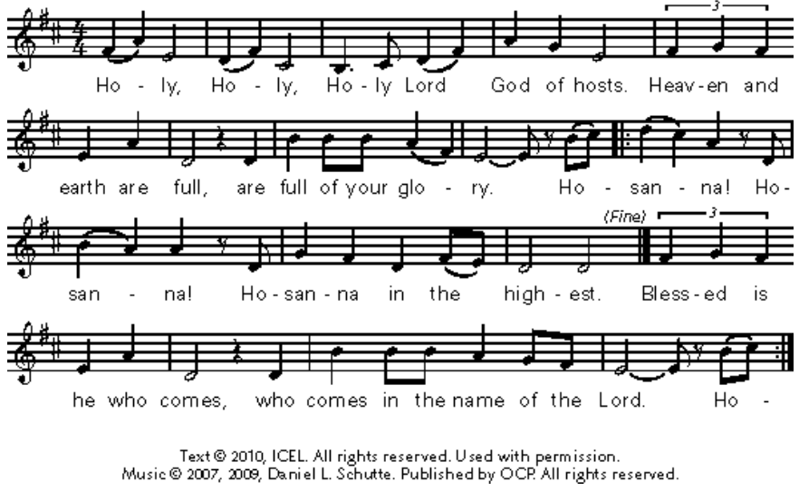
The Prayer of Humble Access and for Cleansing
(the people kneeling or sitting):
Minister: Let us pray together:
All: We do not presume to come to this your table, O merciful Lord, trusting in our own righteousness, but in your many and great mercies. We are not worthy so much as to gather up the crumbs under your table. But You are the same Lord, whose nature is always to have mercy: Grant us, therefore, gracious Lord, so to experience the spiritual presence of your dear Son Jesus Christ at this your table, that we may be made clean by his body and blood, and that we may evermore dwell in him, and he in us. Deliver us, gracious Lord, from the presumption of coming to this table for solace for ourselves only, and not for strength to serve You and others. Deliver us, gracious Lord, from the presumption of coming to this table for pardon of our sins only, and not for transformation of our lives in your holiness. Amen.
Epiclesis Prayer (the people kneeling or sitting):
Minister: Holy and gracious Father, in your infinite love You made us for yourself; and, when we had fallen into sin and become subject to evil and death, You sent Jesus Christ, your only and eternal Son, to share our human nature, to live and die as one of us, to reconcile us to You, the God and Father of all. He stretched out his arms upon the cross and offered himself, in obedience to your will, a perfect sacrifice for the sins of the whole world. Recalling now his death, resurrection, and ascension, we offer You these gifts. Sanctify them by your Holy Spirit to be for us the Body and Blood of your Son, the holy food and drink of new and unending life in him. Sanctify us also, that we may faithfully receive this holy Sacrament, and serve You in unity, constancy, and peace; and at the last day bring us with all your saints into the joy of your eternal kingdom. We ask this through Jesus Christ, your Son, our Lord; through him, and with him, and in him, in the unity of the Holy Spirit, all honor and glory are yours, O Father Almighty, now and forever.
All: Amen.
The Words of Institution (the people kneeling or sitting):
Minister: Our Lord Jesus Christ, on the night that he was betrayed took bread; and when he had given thanks, he broke it, and gave it to his disciples, saying, Take, eat; this is my Body which is given for you: Do this in remembrance of me.
Likewise, after supper, he took the cup; and when he had given thanks, he gave it to them, saying, Drink this, all of you; for this is my blood of the New Testament, which is shed for you, and for many, for the remission of sins: Do this, as often as you shall drink it, in remembrance of me.
All: Amen.
Minister: Therefore, we proclaim: Alleluia! Christ is risen.
People: The Lord is risen indeed. Alleluia.
The Fraction:
Minister: Alleluia! Christ our passover is sacrificed for us.
People: Therefore let us keep the feast. Alleluia.

Fraction Anthem (the people kneeling or sitting, singing):
(The cantor sings the first line, and then all sing the other lines.)
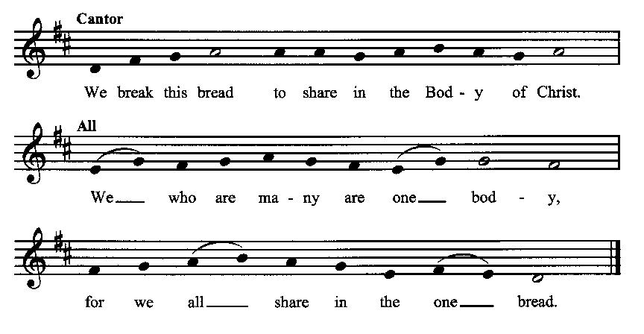
Minister: The gifts of God for the people of God. Take them in remembrance that Christ died for you and rose again, and feed on him in your hearts by faith with thanksgiving.
Communion Hymn (cantors only, the people kneeling or sitting):
“Praise we in songs of victory That love, that life which cannot die, And sing with hearts uplifted high: Alleluia! Alleluia! Alleluia!
Thy name we bless, O risen Lord, And sing today with one accord The life laid down, the life restored: Alleluia! Alleluia! Alleluia!” (Good Christians All, Rejoice and Sing, vv. 3-4; Cyril Alington, alt.)
The Communion, open to all: (After the minister(s) and acolyte(s) are served, the people come forward to receive, as space is available. The people kneel if they are able, or STAND in accord with the practice of the ancient church during Easter, symbolic of being raised up with Christ in his victory. Communion by intincture: The people receive the Bread in their open hands, continue to hold it, then dip the Bread in the cup, and then consume.) They return to their seats via the side aisles.
Renewal of the Mutual Invocation of God’s Grace for the Eucharist:
Minister: The Lord be with you.
People: And also with you.
The Prayer of Thanksgiving and Living Sacrifice:
(The minister kneeling, the people kneeling or sitting):
Minister: Let us pray together:
All: O Lord and Heavenly Father, we heartily thank You because You feed us, in these holy mysteries, with the spiritual food of the most precious Body and Blood of your Son our Savior Jesus Christ; because by this You assure us of your favor and goodness toward us; because we are living members of the body of your Son and heirs of your eternal kingdom. We ask You to accept this our sacrifice of praise and thanksgiving, and to grant that by the merits and death of your Son Jesus Christ and through faith in him, we and all your whole Church may obtain all of the benefits of his passion. And here we offer and present unto You, O Lord, ourselves, our souls and bodies, to be a reasonable, holy, and living sacrifice unto You; humbly asking You that we may be filled with your grace and heavenly benediction; through Jesus Christ our Lord; by whom, and with whom, in the Unity of the Holy Spirit, all honor and glory be unto You, O Father Almighty, world without end. AMEN.

The Gloria Prayer of Praise and Thanksgiving (all standing):
Minister: Let us pray together:
All: Glory be to God on high, and on earth peace, good-will toward all people. We praise You, we bless You, we worship You, we glorify You, we give thanks to You for your great glory, O Lord God, heavenly King, God the Father Almighty. For You only are the Holy One, You only are the Lord, You only, O Christ, with the Holy Spirit, are most high in the glory of God the Father. Amen.
ACTS OF DISMISSAL
Recessional Hymn (all standing, singing):
Let All Things Now Living (No. 451)
The Prayer of Benediction:
Minister: May the power of God that raised Jesus from the dead raise us up with him also and give life to our mortal bodies; and may the blessing of God Almighty, the Father, the Son, and the Holy Spirit, be among you, and remain with you always.
All: Amen.
Minister: Let us go forth in the power of the risen Christ.
People: Thanks be to God. Alleluia. Alleluia.
(The people then be seated.)
Greetings and Announcements
Postlude:
(The people sit and remain quiet until the candles are extinguished and the organ raises its voice.)

_________________________________________________________
Based on, and freely adapted from,
John Wesley’s Order for the Administration of the Lord’s Supper,
the 1662 and 1979 editions of The Book of Common Prayer, and
Common Worship: Services and Prayers for the Church of England
_____________________________________________________________

Scripture lessons for April 28 (Easter 5):
Acts 8:26-40; Psalm 66:1-11; I John 3:11-24; John 14:15-21

Parish Prayer for This Week and Next Sunday
Those living on Larch Street
__________________________________________

Parish Notices

Tea & Tomes

Our next book will be The Abolition of Man by C. S. Lewis. The book critiques the idea of moral relativism and points out the consequences for society of denying objective values. These consequences are far greater than you might think. Even though the book is 80 years old, it has proven prophetic as we are now living in the world it warned of. Epworth is making a few copies available, or you can obtain a copy from the public library. The book discussion is tentatively planned for late June, so there is plenty of time to get the book and read it.

Updated Directories
The latest Epworth directories are now available in the Narthex. Feel free to pick one up.

Coming Events at Epworth
Today, 10:00 am Word & Table Service
Today, 11:30 am Fellowship
Today, 11:40 am Afterword (moderated discussion)
Thursday, 7:00 pm Evening Prayers
Tuesday, 23 April Board Meeting
Sunday, 12 May Ascension Sunday
Sunday, 19 May Pentecost Sunday
Sunday, 26 May Trinity Sunday

April Birthdays & Anniversaries

02 – Robyn Millar
05 – Jessica Crosswhite
16 – Dorothy Millard

Sermon Notes

Epworth Church Office Email
epworthchapel.office@gmail.com
All correspondence for the office should be sent to this email address.

Pastor Crow Contact Information
Healing prayer is provided every week upon request
Rev. John Crow, Interim Rector and Pastor
208-501-4037
jdowningcrow@hotmail.com

