Service of Word & Table

at

Epworth Chapel on the Green
6110 W. Northview Street, Boise, Idaho 83704
208-336-3951
www.epworthchapelonthegreen.org

The Rev. John Crow, Rector and Pastor
208-501-4037

April 14, 2024, 10:00 a.m.

Third Sunday of Easter

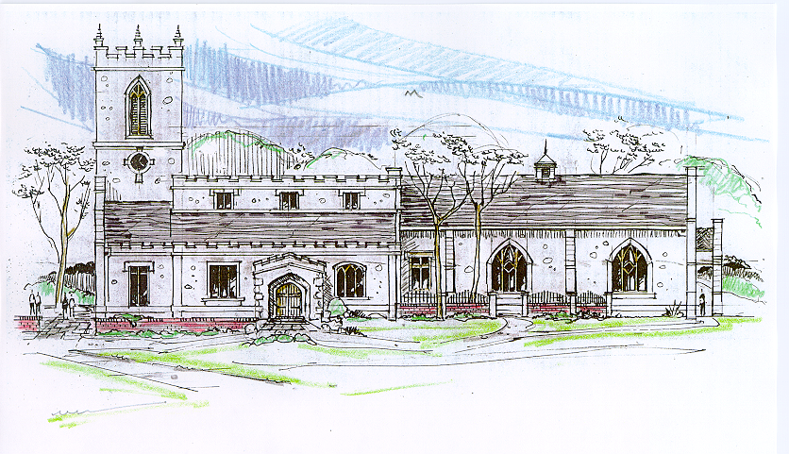
Then the angel spoke to the women, “Don’t be afraid!” He said.
“I know you are looking for Jesus, who was crucified. He isn’t here!
He has been raised from the dead, just as he said would happen. “
Matthew 28:5-6, (NLT)
_______________________________________________________
“Through the deep current of the historical church we will collaboratively serve and reach the lost in order to make disciples who love Jesus.”
_____________________________________________________________
This service will be live streamed, and in the course of that any or all persons who attend may be filmed. Remaining in the service will constitute your consent to appear in the live-streamed, recorded, and published service

Rector and Pastor: The Rev. John Crow
Cantors: Bryan Vanshur, Shannon Nichols
Readers:
Old Testament: Adam Graham
Psalm: Adam Graham
Epistle: Bryan Vanshur
Acolytes: Stephen Crow, Josiah Crow, Corbin Crosswhite, Jessica Crosswhite
Jr. Acolytes: Asher Crow, Corbin, Jessica, & Lizzie Crosswhite
Usher: Kendra Millar
_______________________________
ACTS OF ENTRANCE
(The people enter and remain in prayer and meditation.)
Entrance canticle (cantors only):
“On a hill far away stood an old rugged cross, The emblem of suffering and shame; And I love that old cross where the dearest and best For a world of lost sinners was slain. So I’ll cherish the old rugged cross, till my trophies at last I lay down; I will cling to the old rugged cross, and exchange it some day for a crown.
Oh, that old rugged cross so despised by the world, Has a wondrous attraction for me; For the dear Lamb of God left His glory above, To bear it to dark Calvary. So I’ll cherish the old rugged cross, till my trophies at last I lay down; I will cling to the old rugged cross, and exchange it some day for a crown.” (The Old Rugged Cross, vv. 1-2; George Bennard)
Processional Hymn (all standing):
Praise the Lord! Ye Heavens Adore Him (No. 163)
Minister: Blessed be God: Father, Son, and Holy Spirit.
People: And blessed be his kingdom, now and forever.
Minister: Alleluia! Christ is risen.
People: The Lord is risen indeed. Alleluia!

Lord’s Prayer: (found on page 1 in the pew hymnal)
Minister: Let us pray…

The Collect for Purity:
Minister: Almighty God, unto whom all hearts are open, all desires known, and from whom no secrets are hid; cleanse the thoughts of our hearts by the inspiration of your Holy Spirit, that we may perfectly love You, and worthily magnify your holy Name, through Christ our Lord.
All: Amen.
The Gloria Hymn (all standing):
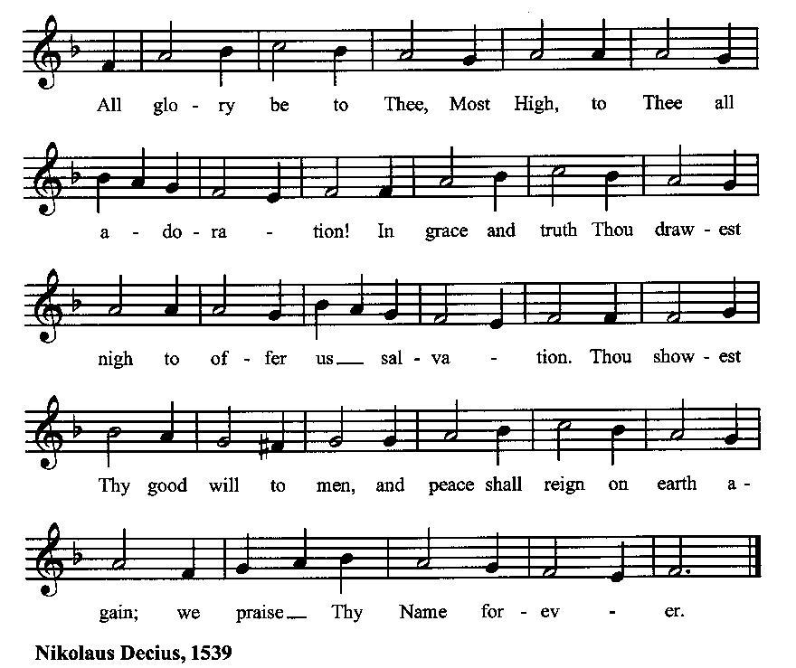

Minister: Holy God, Holy and Mighty, Holy Immortal One,
People: Have mercy upon us.
SERVICE OF THE WORD
Mutual Invocation of the Grace of God for the Service of the Word:
Minister: The Lord be with you.
People: And also with you.
(The people then be seated.)

The Great Commandments (the people sitting):
Minister: Hear what our Lord Jesus Christ says. You shall love the Lord your God with all your heart, and with all your soul, and with all your mind. This is the first and great commandment. And the second is like unto it: You shall love your neighbor as yourself. On these two commandments hang all the Law and the Prophets.

The Kyrie (the people sitting):
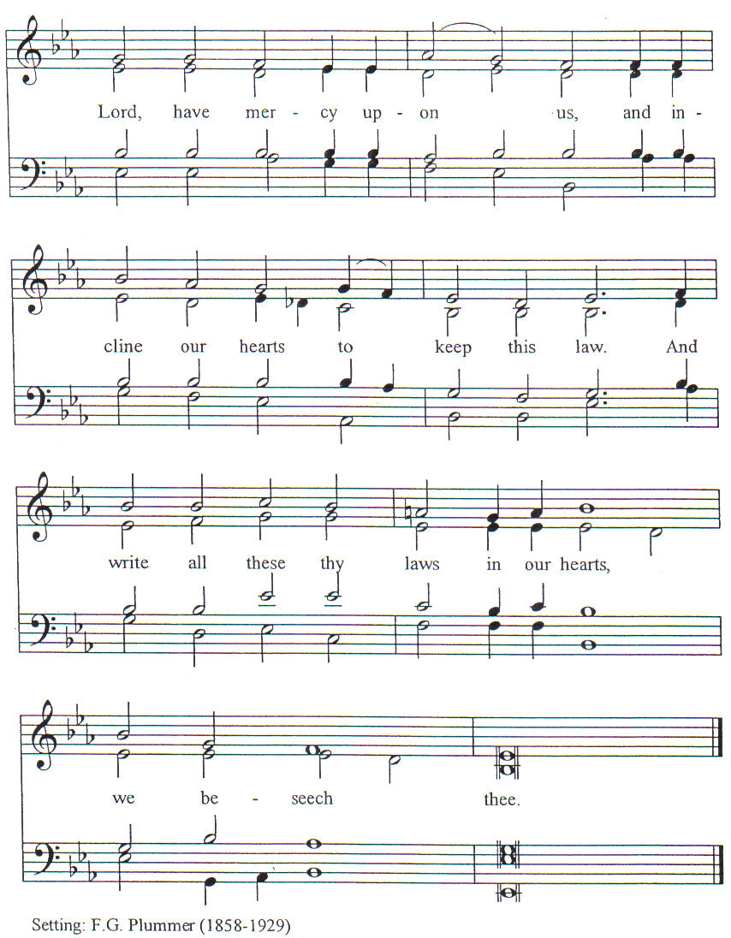

New Testament Lesson (the people sitting):
Reader: The New Testament reading is written in the fourth chapter of the Acts of the Apostles, beginning at verse 5:
5 On the morrow their rulers and elders and scribes were gathered together in Jerusalem,
6 with Annas the high priest and Ca′iaphas and John and Alexander, and all who were of the high-priestly family.
7 And when they had set them in the midst, they inquired, “By what power or by what name did you do this?”
8 Then Peter, filled with the Holy Spirit, said to them, “Rulers of the people and elders,
9 if we are being examined today concerning a good deed done to a cripple, by what means this man has been healed,
10 be it known to you all, and to all the people of Israel, that by the name of Jesus Christ of Nazareth, whom you crucified, whom God raised from the dead, by him this man is standing before you well.
11 This is the stone which was rejected by you builders, but which has become the head of the corner.
12 And there is salvation in no one else, for there is no other name under heaven given among men by which we must be saved.”
13 Now when they saw the boldness of Peter and John, and perceived that they were uneducated, common men, they wondered; and they recognized that they had been with Jesus.
14 But seeing the man that had been healed standing beside them, they had nothing to say in opposition.
15 But when they had commanded them to go aside out of the council, they conferred with one another,
16 saying, “What shall we do with these men? For that a notable sign has been performed through them is manifest to all the inhabitants of Jerusalem, and we cannot deny it.
17 But in order that it may spread no further among the people, let us warn them to speak no more to any one in this name.”
18 So they called them and charged them not to speak or teach at all in the name of Jesus.
19 But Peter and John answered them, “Whether it is right in the sight of God to listen to you rather than to God, you must judge;
20 for we cannot but speak of what we have seen and heard.”
21 And when they had further threatened them, they let them go, finding no way to punish them, because of the people; for all men praised God for what had happened.
22 For the man on whom this sign of healing was performed was more than forty years old. (RSV)
Reader: The Word of the Lord.
People: Thanks be to God.
The Psalm: (The people sit for the responsive reading, by half-verse, of a portion of Psalm 98, a song of praise for God’s great victory.)
Reader: The Psalm is chapter 98, beginning at verse 1:
Reader: 1 Sing to the Lord a new song,
People: for he has done marvelous things.
Reader: 2 With his right hand and his holy arm
People: has he won for himself the victory.
Reader: 3 The Lord has made known his victory;
People: his righteousness has he openly shown in the sight of the nations.
Reader: 4 He remembers his mercy and faithfulness to the house of Israel,
People: and all the ends of the earth have seen the victory of our God.
Reader: 5 Shout with joy to the LORD, all you lands;
People: lift up your voice, rejoice, and sing. (BCP)
Gloria Patri (the people sitting)
Reader: Glory be to the Father, and to the Son, and to the Holy Spirit;
People: As it was in the beginning, is now and ever shall be, world without end. Amen.
Collect for the Third Sunday of Easter:
Minister: O God, whose blessed Son made himself known to his disciples in the breaking of bread: Open the eyes of our faith,
that we may behold him in all his redeeming work; who lives and reigns with you, in the unity of the Holy Spirit, one God, now and for ever.
All: Amen.

The Epistle (the people sitting):
Reader: The epistle lesson is written in the first chapter of the First letter of John, beginning at verse 1:
- That which was from the beginning, which we have heard, which we have seen with our eyes, which we have looked upon and touched with our hands, concerning the word of life—
- the life was made manifest, and we saw it, and testify to it, and proclaim to you the eternal life which was with the Father and was made manifest to us—
- that which we have seen and heard we proclaim also to you, so that you may have fellowship with us; and our fellowship is with the Father and with his Son Jesus Christ.
- And we are writing this that our joy may be complete.
- This is the message we have heard from him and proclaim to you, that God is light and in him is no darkness at all.
- If we say we have fellowship with him while we walk in darkness, we lie and do not live according to the truth;
- but if we walk in the light, as he is in the light, we have fellowship with one another, and the blood of Jesus his Son cleanses us from all sin.
- If we say we have no sin, we deceive ourselves, and the truth is not in us.
- If we confess our sins, he is faithful and just, and will forgive our sins and cleanse us from all unrighteousness.
- If we say we have not sinned, we make him a liar, and his word is not in us.
- My little children, I am writing this to you so that you may not sin; but if any one does sin, we have an advocate with the Father, Jesus Christ the righteous;
- and he is the expiation for our sins, and not for ours only but also for the sins of the whole world. (RSV)
Reader: Here ends the Epistle.
People: Thanks be to God.
Sequence Hymn (all standing, and turning toward the Gospel reading):
Rejoice, Ye Pure in Heart, vv. 1-3 (No. 183)
The Gospel:
Minister: The holy Gospel is written in the twenty-fourth chapter of the Gospel according to Luke, beginning at verse 36:
Minister:
36 As they were saying this, Jesus himself stood among them.
37 But they were startled and frightened, and supposed that they saw a spirit.
38 And he said to them, “Why are you troubled, and why do questionings rise in your hearts?
39 See my hands and my feet, that it is I myself; handle me, and see; for a spirit has not flesh and bones as you see that I have.”
40 [And when he had said this, he showed them his hands and his feet.]*
41 And while they still disbelieved for joy, and wondered, he said to them, “Have you anything here to eat?”
42 They gave him a piece of broiled fish,
43 and he took it and ate before them.
44 Then he said to them, “These are my words which I spoke to you, while I was still with you, that everything written about me in the law of Moses and the prophets and the psalms must be fulfilled.”
45 Then he opened their minds to understand the scriptures,
46 and said to them, “Thus it is written, that the Christ should suffer and on the third day rise from the dead,
47 and that repentance and forgiveness of sins should be preached in his name to all nations, beginning from Jerusalem.
48 You are witnesses of these things.
49 And behold, I send the promise of my Father upon you; but stay in the city, until you are clothed with power from on high.” (RSV)
Minister: Alleluia! The Gospel of the Lord.
People: Praise to You, Lord Christ. Alleluia!
*Many ancient manuscripts don’t include v. 40
Sequence Hymn (the people standing):
Rejoice, Ye Pure in Heart, vv. 4-5 (No. 183)
[Elementary age children may exit for Children's Worship in the Parish Hall.
They will return to the service at the Passing of the Peace.]
Minister: Grace be unto you, and peace, from our Lord Jesus Christ.
All: Amen. (The people then be seated.)
The Sermon
Minister: In the name of the Father, the Son and the Holy Spirit.

Silence, for review of the sermon, and for meditative prayer

SERVICE OF THE TABLE: THE GREAT THANKSGIVING
The Nicene Creed (all standing): (found on page II in the pew hymnal)
Minister: Let us confess our faith, saying…

Minister: (The people sitting) Yours, O Lord, is the greatness, the power, the glory, the victory, and the majesty. For everything in heaven and on earth is yours. Yours, O Lord, is the kingdom, and You are exalted as head over all. (I Chronicles 29:11)
Offertory:
Offering Hymn (the people standing):
From All That Dwell Below the Skies (No. 484)
Minister: All things come from You, O Lord,
People: And of your own have we given You.
The Prayers of the People (the people kneeling or sitting):
Minister: Let us pray for the Church and the world. For the unity of the Church throughout the world, that we might faithfully preach the Gospel to the ends of the earth, let us pray to the Lord:
People: Lord, hear our prayer.
Minister: For the persecuted church, and for its persecutors, that You would turn their hearts, let us pray to the Lord:
People: Lord, hear our prayer.
Minister: For our President and all who govern and hold authority in our nation and in the world, let us pray to the Lord:
People: Lord, hear our prayer.
Minister: For the good earth which You have given us, and for the wisdom and will to conserve it, let us pray to the Lord:
People: Lord, hear our prayer.
Minister: For all ministers of your Gospel, that they might faithfully preach your Word, administer your sacraments, and care for your people, let us pray to the Lord:
People: Lord, hear our prayer.
Minister: For the peace of the world, that a spirit of respect and forbearance may grow among all nations and peoples, let us pray to the Lord:
People: Lord, hear our prayer.
Minister: For all those who do not yet believe, and for those who have lost their faith, that in due time we may all stand reconciled before You, let us pray to the Lord:
People: Lord, hear our prayer.
Minister: For the poor and the oppressed, prisoners and captives, the unemployed, and all who are in need or trouble, let us pray to the Lord:
People: Lord, hear our prayer.
Minister: For our enemies and all who wish us harm, and for all whom we have injured or offended, let us pray to the Lord:
People: Lord, hear our prayer.
Minister: For this congregation, that we might show forth your glory in all that we do; and for those who have commended themselves to our prayers, including these: _____________:
[Nation: Tajikistan
Denomination: Church of the Lutheran Brethren
Congregation: St. Andrew’s Episcopal Church in Farmer’s Branch, TX, and the Rev. Roy Thomas
Ministry: Asbury Theological Seminary
Parishioners: Those living on Hartman Street],
Grant that all of these may be delivered from anxiety, and live in joy, peace, and health.
(Please add your own intentions, either silently or aloud.)
Minister: Let us pray to the Lord:
People: Lord, hear our prayer.
Minister: We bless your holy Name for the thanksgivings of your people, including these: _________; for those in every generation in whom Christ has been honored; Give us grace to follow their good examples, that with them we may be partakers of your heavenly kingdom.
(Please add your intentions, either silently or aloud.)
Minister: Let us pray to the Lord:
People: Lord, hear our prayer
Collect:
Minister: O God our King, by the resurrection of your Son Jesus Christ on the first day of the week, You conquered sin, put death to flight, and gave us the hope of everlasting life: Redeem all our days by this victory; forgive our sins, banish our fears, make us bold to praise You and to do your will; and steel us to wait for the consummation of your kingdom on the last great day; through Jesus Christ our Lord.
All: Amen. (The people sit.)
Preparation for Holy Communion (the people sitting):
Minister: The Lord’s Supper was ordained by God to be a means of conveying grace according to the need of each person. Those for whom it was ordained are all those who know and feel that they want the grace of God, to restrain them from sin, or to forgive their sins, or to assure them of pardon, or to renew their souls in the image of God, or to enter into the holy presence of God in communion with him. No preparation is indispensably necessary, other than a desire to receive the grace God pleases to give. No fitness or church membership is required at the time of communicating, other than a sense of our state, of our utter sinfulness and helplessness apart from Christ. Therefore, if you want such grace as God pleases to give to you, draw near with faith, and as you prepare to receive this holy sacrament to your comfort and strength, make your sincere confession to Almighty God, kneeling if you wish and are able, or otherwise sitting.
The Prayer of Confession, Petition and Thanksgiving:
(The minister kneels, and the people kneel or sit.)
Minister: Let us pray together:
All: Almighty God, Father of our Lord Jesus Christ, Maker of all things, Judge of all persons: We have erred and strayed from your ways like lost sheep. We have followed too much the devices and desires of our own hearts. You have shown us the way of life through your Son, Jesus Christ. Where there is sin or falling short of your will in our lives, or any spiritual pride, carelessness or presumption on our part, or any failure to see or know your good and righteous will, we earnestly repent and are heartily sorry for our misdoings. Forgive us all that is past, grant that we may ever serve and please You in newness of life, and accept our thanksgiving for the wondrous grace and forgiveness You extend to us, to the honor and glory of your Name, through Jesus Christ our Lord. Amen.
The Agnus Dei (the people kneeling or sitting, singing):
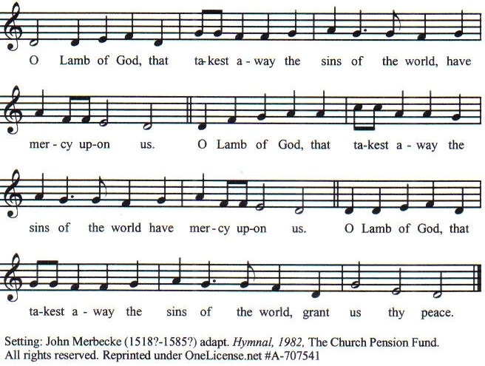

Prayer for Absolution (the people kneeling or sitting):
Minister: Almighty God, our heavenly Father, who of your great mercy has promised forgiveness of sins to all those who with hearty repentance and true faith turn unto You; Have mercy upon us; pardon and deliver us from all our sins, confirm and strengthen us in all goodness, and bring us to everlasting life, through Jesus Christ our Lord.
All: Amen.
The Comforting Words of Forgiveness (the people sitting):
Minister: Hear what comforting words our Savior Christ says to all who truly turn to him: Come to me, all you who are weary and carry heavy burdens, and I will give you rest. God so loved the world that he gave his only Son, so that everyone who believes in him will not perish but have eternal life. Hear also what St. Paul says: Christ Jesus came into the world to save sinners. Hear also what St. John says: If anyone sins, we have an Advocate with the Father, Jesus Christ the righteous: and he is the atonement for our sins.

The Passing of the Peace:
Minister: The peace of the Lord be always with you.
People: And also with you.
Minister: As the peace of Christ has been extended to you, extend the peace of the Lord to one another, and greet one another in the name of the Lord. (The people rise and remain standing.)
(The people greet those near to them, saying, “The peace of the Lord be with you,” or, “Peace be with you,” or simply, “Peace.” They respond to one another, “And also with you,” or simply, “Peace”.)
Hymn of Entry Into the Heavenly Worship (the people standing):
I Know That My Redeemer Lives (No. 173)
Preparation for the Table:
(Minister: I wash my hands in innocence, and go about your altar, O LORD, proclaiming aloud your praise and telling of all your wonderful deeds). [Psalm 26:6-7, NIV]
The Sursum Corda (all standing):
Minister: The Lord be with you.
People: And also with you.
Minister: Lift up your hearts.
People: We lift them up unto the Lord.
Minister: Let us give thanks unto our Lord God.
People: It is meet and right so to do.
The Salutation:
Minister: It is very meet, right, and our gladsome duty, that we should at all times, and in all places, give thanks unto You, O Lord, Holy Father, Almighty, Everlasting God.
The Preface:
Minister: But chiefly we are bound to praise You for the glorious resurrection of your Son Jesus Christ our Lord; for he is the very Paschal Lamb, who was sacrificed for us, and he has taken away the sin of the world. By his death He has destroyed death, and by his rising to life again He has won for us everlasting life.
Minister: Therefore, with Angels and Archangels and with all the company of heaven, we laud and magnify your glorious Name, evermore praising You, and saying,

The Sanctus:
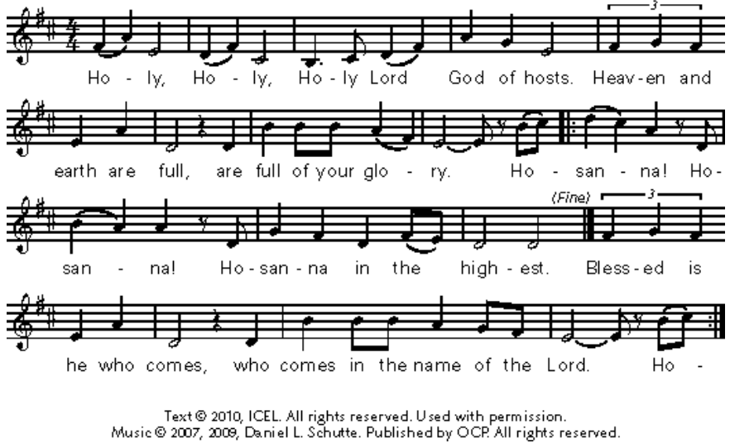

The Prayer of Humble Access and for Cleansing
(the people kneeling or sitting):
Minister: Let us pray together:
All: We do not presume to come to this your table, O merciful Lord, trusting in our own righteousness, but in your many and great mercies. We are not worthy so much as to gather up the crumbs under your table. But You are the same Lord, whose nature is always to have mercy: Grant us, therefore, gracious Lord, so to experience the spiritual presence of your dear Son Jesus Christ at this your table, that we may be made clean by his body and blood, and that we may evermore dwell in him, and he in us. Deliver us, gracious Lord, from the presumption of coming to this table for solace for ourselves only, and not for strength to serve You and others. Deliver us, gracious Lord, from the presumption of coming to this table for pardon of our sins only, and not for transformation of our lives in your holiness. Amen.

Epiclesis Prayer (the people kneeling or sitting):
Minister: Holy and gracious Father, in your infinite love You made us for yourself; and, when we had fallen into sin and become subject to evil and death, You sent Jesus Christ, your only and eternal Son, to share our human nature, to live and die as one of us, to reconcile us to You, the God and Father of all. He stretched out his arms upon the cross and offered himself, in obedience to your will, a perfect sacrifice for the sins of the whole world. Recalling now his death, resurrection, and ascension, we offer You these gifts. Sanctify them by your Holy Spirit to be for us the Body and Blood of your Son, the holy food and drink of new and unending life in him. Sanctify us also, that we may faithfully receive this holy Sacrament, and serve You in unity, constancy, and peace; and at the last day bring us with all your saints into the joy of your eternal kingdom. We ask this through Jesus Christ, your Son, our Lord; through him, and with him, and in him, in the unity of the Holy Spirit, all honor and glory are yours, O Father Almighty, now and forever.
All: Amen.
The Words of Institution (the people kneeling or sitting):
Minister: Our Lord Jesus Christ, on the night that he was betrayed took bread; and when he had given thanks, he broke it, and gave it to his disciples, saying, Take, eat; this is my Body which is given for you: Do this in remembrance of me.
Likewise, after supper, he took the cup; and when he had given thanks, he gave it to them, saying, Drink this, all of you; for this is my blood of the New Testament, which is shed for you, and for many, for the remission of sins: Do this, as often as you shall drink it, in remembrance of me.
All: Amen.
Minister: Therefore, we proclaim: Alleluia! Christ is risen.
People: The Lord is risen indeed. Alleluia.
The Fraction:
Minister: Alleluia! Christ our passover is sacrificed for us.
People: Therefore let us keep the feast. Alleluia.

Fraction Anthem (the people kneeling or sitting, singing):
(The cantor sings the first line, and then all sing the other lines.)
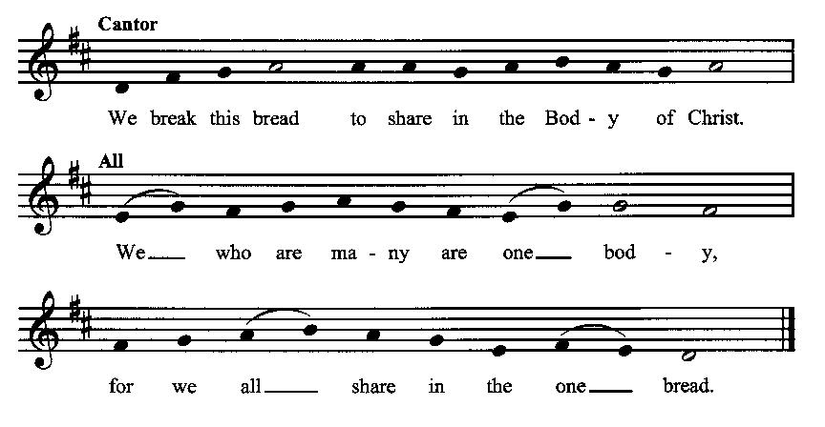
Minister: The gifts of God for the people of God. Take them in remembrance that Christ died for you and rose again, and feed on him in your hearts by faith with thanksgiving.
Communion Hymn (cantors only, the people kneeling or sitting):
“In the old rugged cross, stained with blood so divine, A wondrous beauty I see; For ‘twas on that old cross Jesus suffered and died, To pardon and sanctify me. So I’ll cherish the old rugged cross, till my trophies at last I lay down; I will cling to the old rugged cross, and exchange it some day for a crown.
To the old rugged cross I will ever be true, Its shame and reproach gladly bear; Then He’ll call me some day to my home far away, Where his glory forever I’ll share. So I’ll cherish the old rugged cross, till my trophies at last I lay down; I will cling to the old rugged cross, and exchange it some day for a crown.” (The Old Rugged Cross, vv. 3-4; George Bennard)
The Communion, open to all: (After the minister(s) and acolyte(s) are served, the people come forward to receive, as space is available. The people kneel if they are able, or STAND in accord with the practice of the ancient church during Easter, symbolic of being raised up with Christ in his victory. Communion by intincture: The people receive the Bread in their open hands, continue to hold it, then dip the Bread in the cup, and then consume.) They return to their seats via the side aisles.
Renewal of the Mutual Invocation of God’s Grace for the Eucharist:
Minister: The Lord be with you.
People: And also with you.
The Prayer of Thanksgiving and Living Sacrifice:
(The minister kneeling, the people kneeling or sitting):
Minister: Let us pray together:
All: O Lord and Heavenly Father, we heartily thank You because You feed us, in these holy mysteries, with the spiritual food of the most precious Body and Blood of your Son our Savior Jesus Christ; because by this You assure us of your favor and goodness toward us; because we are living members of the body of your Son and heirs of your eternal kingdom. We ask You to accept this our sacrifice of praise and thanksgiving, and to grant that by the merits and death of your Son Jesus Christ and through faith in him, we and all your whole Church may obtain all of the benefits of his passion. And here we offer and present unto You, O Lord, ourselves, our souls and bodies, to be a reasonable, holy, and living sacrifice unto You; humbly asking You that we may be filled with your grace and heavenly benediction; through Jesus Christ our Lord; by whom, and with whom, in the Unity of the Holy Spirit, all honor and glory be unto You, O Father Almighty, world without end. AMEN.

The Gloria Prayer of Praise and Thanksgiving (all standing):
Minister: Let us pray together:
All: Glory be to God on high, and on earth peace, good-will toward all people. We praise You, we bless You, we worship You, we glorify You, we give thanks to You for your great glory, O Lord God, heavenly King, God the Father Almighty. For You only are the Holy One, You only are the Lord, You only, O Christ, with the Holy Spirit, are most high in the glory of God the Father. Amen.
ACTS OF DISMISSAL
Recessional Hymn (all standing, singing):
All Praise to God Above (No. 171)
The Prayer of Benediction:
Minister: May the power of God that raised Jesus from the dead raise us up with him also and give life to our mortal bodies; and may the blessing of God Almighty, the Father, the Son, and the Holy Spirit, be among you, and remain with you always.
All: Amen.
Minister: Let us go forth in the power of the risen Christ.
People: Thanks be to God. Alleluia. Alleluia.
(The people then be seated.)

Greetings and Announcements
Postlude:
(The people sit and remain quiet until the candles are extinguished and the organ raises its voice.)

_________________________________________________________
Based on, and freely adapted from,
John Wesley’s Order for the Administration of the Lord’s Supper,
the 1662 and 1979 editions of The Book of Common Prayer, and
Common Worship: Services and Prayers for the Church of England
_____________________________________________________________

Scripture lessons for April 21 (Easter 4):
Acts 4:23-31; Psalm 100; I John 3:1-10; John 10:11-16

Parish Prayer for This Week and Next Sunday
Those living on Joretta Drive
__________________________________________

Parish Notices
Tea & Tomes
Our next book will be The Abolition of Man by C. S. Lewis. The book critiques the idea of moral relativism and points out the consequences for society of denying objective values. These consequences are far greater than you might think. Even though the book is 80 years old, it has proven prophetic as we are now living in the world it warned of. Epworth is making a few copies available, or you can obtain a copy from the public library. The book discussion is tentatively planned for late June, so there is plenty of time to get the book and read it.

Updated Directories
The latest Epworth directories are now available in the Narthex. Feel free to pick one up.

Coming Events at Epworth
Today, 10:00 am Word & Table Service
Today, 11:30 am Fellowship
Today, 11:40 am Afterword (moderated discussion)
Thursday, 7:00 pm Evening Prayers
Tuesday, 23 April Board Meeting

April Birthdays & Anniversaries

02 – Robyn Millar
05 – Jessica Crosswhite
16 – Dorothy Millard

Sermon Notes

Epworth Church Office Email
epworthchapel.office@gmail.com
All correspondence for the office should be sent to this email address.

Pastor Crow Contact Information
Healing prayer is provided every week upon request
Rev. John Crow, Interim Rector and Pastor
208-501-4037
jdowningcrow@hotmail.com

