Easter Sunday
Service of Word & Table

at

Epworth Chapel on the Green
6110 W. Northview Street, Boise, Idaho 83704
208-336-3951
www.epworthchapelonthegreen.org

The Rev. John Crow, Rector and Pastor
208-501-4037

March 31, 2024, 10:00 a.m.
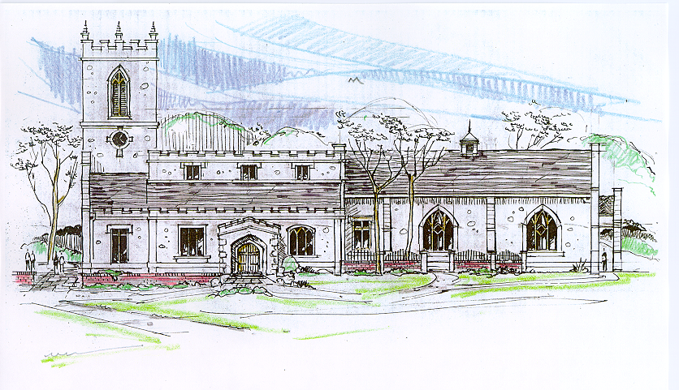
Then the angel spoke to the women, “Don’t be afraid!” He said. “I know you are looking for Jesus , who was crucified. He isn’t here! He has been raised from the dead, just as he said would happen. “ Matthew 28:5-6 (NLT)
_______________________________________________

“Through the deep current of the historical church we will collaboratively serve and reach the lost in order to make disciples who love Jesus.”
_____________________________________________
This service will be live streamed, and in the course of that any or all persons who attend may be filmed. Remaining in the service will constitute your consent to appear in the live-streamed, recorded, and published service

Rector and Pastor: The Rev. John Crow
Cantors: Bryan Vanshur, Shannon Nichols
Readers:
New Testament: Bryan Vanshur
Psalm: Bryan Vanshur
Epistle: Josiah Crow
Acolytes: Stephen Crow, Josiah Crow, Corbin Crosswhite, Jessica Crosswhite
Jr. Acolytes: Asher Crow, Corbin, Jessica, & Lizzie Crosswhite
Usher: Asher Crow
_______________________________
ACTS OF ENTRANCE
Prélude:
(The people enter and remain in prayer and meditation.)
Entrance canticle (cantors only):
“Morning has broken like the first morning, black-bird has spoken like the first bird. Praise for the singing! Praise for the morning! Praise for them, springing! Fresh from the Word!
Mine is the sunlight! Mine is the morning born of the one light Eden saw play! Praise with elation, praise every morning, God’s recreation of the new day!” (Morning Has Broken, v. 1, 3; Eleanor Farjeon)
Processional Hymn (all standing):
Crown Him with Many Crowns (No. 170)
Minister: Blessed be God: Father, Son, and Holy Spirit.
People: And blessed be his kingdom, now and forever.
Minister: Alleluia! Christ is risen.
People: The Lord is risen indeed. Alleluia!

Lord’s Prayer: (found on page 1 in the pew hymnal)
Minister: Let us pray…

The Collect for Purity:
Minister: Almighty God, unto whom all hearts are open, all desires known, and from whom no secrets are hid; cleanse the thoughts of our hearts by the inspiration of your Holy Spirit, that we may perfectly love You, and worthily magnify your holy Name, through Christ our Lord.
All: Amen.

The Gloria Hymn (all standing):
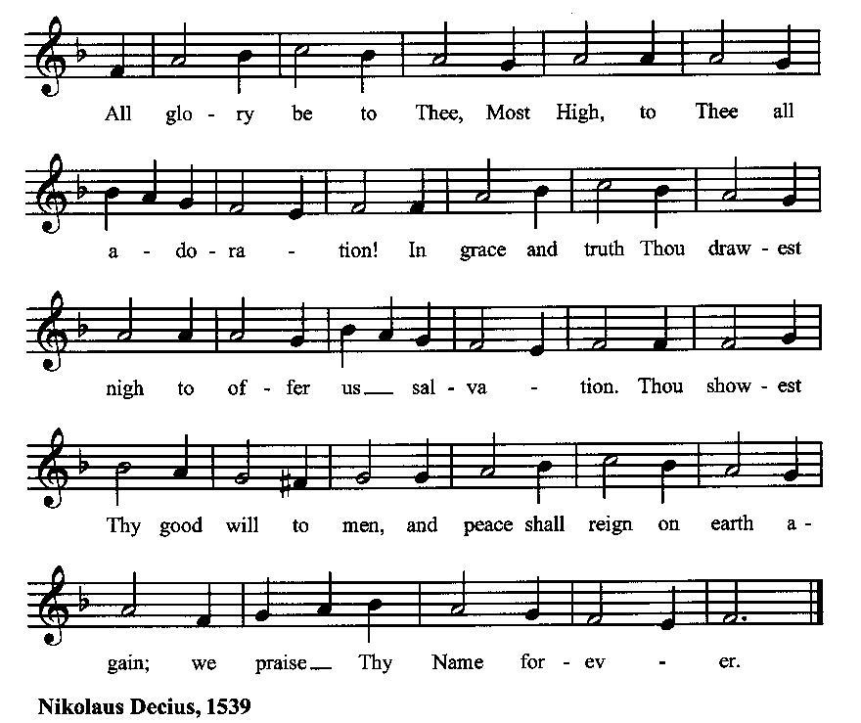

Minister: Holy God, Holy and Mighty, Holy Immortal One,
People: Have mercy upon us.

SERVICE OF THE WORD

Mutual Invocation of the Grace of God for the Service of the Word:
Minister: The Lord be with you.
People: And also with you.
(The people then be seated.)
The Great Commandments (the people sitting):
Minister: Hear what our Lord Jesus Christ says. You shall love the Lord your God with all your heart, and with all your soul, and with all your mind. This is the first and great commandment. And the second is like unto it: You shall love your neighbor as yourself. On these two commandments hang all the Law and the Prophets.

Responsorial canticle (all sitting, singing):
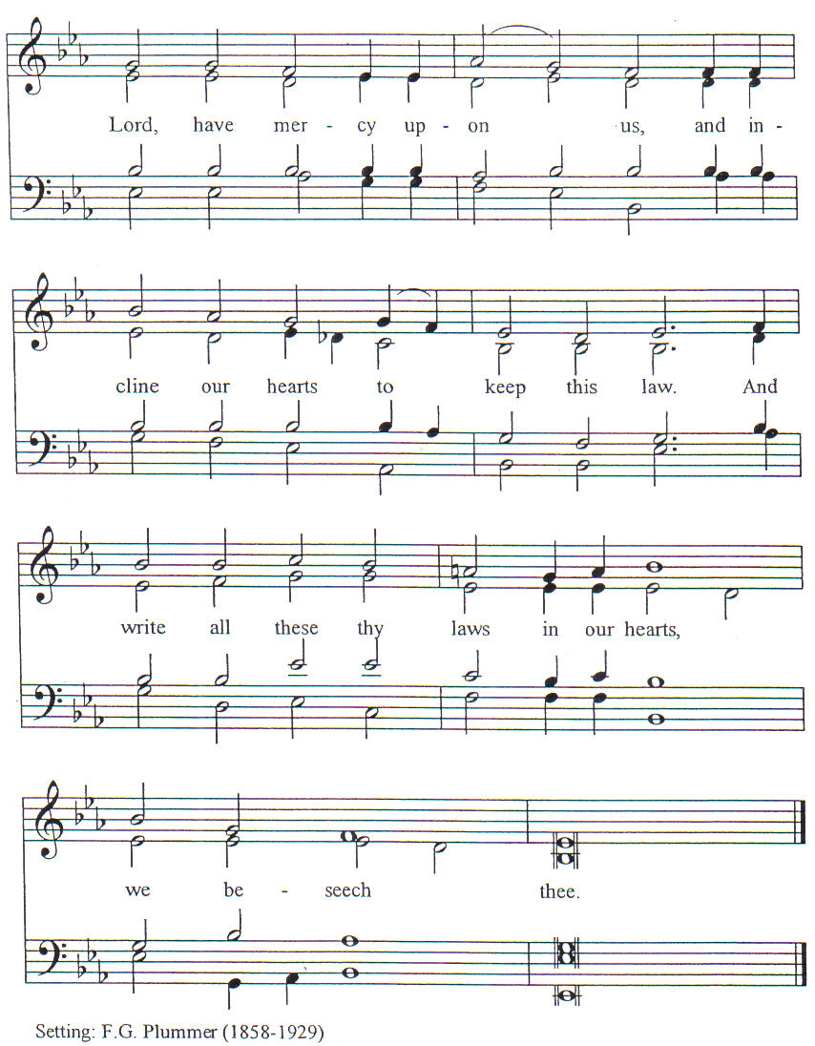

New Testament Lesson (the people sitting):
Reader: The New Testament reading is written in the tenth chapter of the Acts of the Apostles, beginning at verse 34:
34 And Peter opened his mouth and said: “Truly I perceive that God shows no partiality,
35 but in every nation any one who fears him and does what is right is acceptable to him.
36 You know the word which he sent to Israel, preaching good news of peace by Jesus Christ (he is Lord of all),
37 the word which was proclaimed throughout all Judea, beginning from Galilee after the baptism which John preached:
38 how God anointed Jesus of Nazareth with the Holy Spirit and with power; how he went about doing good and healing all that were oppressed by the devil, for God was with him.
39 And we are witnesses to all that he did both in the country of the Jews and in Jerusalem. They put him to death by hanging him on a tree;
40 but God raised him on the third day and made him manifest;
41 not to all the people but to us who were chosen by God as witnesses, who ate and drank with him after he rose from the dead.
42 And he commanded us to preach to the people, and to testify that he is the one ordained by God to be judge of the living and the dead.
43 To him all the prophets bear witness that every one who believes in him receives forgiveness of sins through his name.” (RSV)

Reader: The Word of the Lord.
People: Thanks be to God.
The Psalm:
(The people sit for the responsive reading, by half-verse, of a portion of Psalm 118, a song of praise for God’s triumph and victory.)
Reader: The Psalm is chapter 118, beginning at verse 14:
Reader: 14 The LORD is my strength and my song
People: and he has become my salvation.
Reader: 15 There is a sound of exultation and victory
People: in the tents of the righteous.
Reader: 16 The right hand of the LORD has triumphed!
People: the right hand of the LORD is exalted! The right hand of the LORD has triumphed!
Reader: 17 I shall not die, but live,
People: and declare the works of the LORD.
Reader: 18 The LORD has punished me sorely,
People: but he did not hand me over to death
Reader: 19 Open for me the gates of righteousness;
People: I will enter them; I will offer thanks to the Lord.
Reader: 20 “This is the gate of the LORD;
People: he who is righteous may enter.”
Reader: 21 I will give thanks to you, for you answered me
People: and have become my salvation.
Reader: 22 The same stone which the builders rejected
People: has become the chief cornerstone.
Reader: 23 This is the LORD’s doing,
People: and it is marvelous in our eyes.
Reader: 24 On this day the LORD has acted;
People: we will rejoice and be glad in it. (BCP)
Gloria Patri (the people sitting)
Reader: Glory be to the Father, and to the Son, and to the Holy Spirit.
People: As it was in the beginning, is now and ever shall be, world without end. Amen.
Collect for Easter Sunday:
Minister: Almighty God, who through your only-begotten Son Jesus Christ overcame death and opened to us the gate of everlasting life: Grant that we, who celebrate with joy the day of our Lord’s resurrection, may be raised from the death of sin by your life-giving Spirit; through Jesus Christ our Lord, who lives and reigns with You and the Holy Spirit, one God, now and for ever.
All: Amen.
The Epistle (the people sitting):
Reader: The epistle lesson is written in the third chapter of the letter of St. Paul to the Colossians, beginning at verse 1:
- If then you have been raised with Christ, seek the things that are above, where Christ is, seated at the right hand of God.
- Set your minds on things that are above, not on things that are on earth.
- For you have died, and your life is hid with Christ in God.
- When Christ who is our life appears, then you also will appear with him in glory. (RSV)
Reader: Here ends the Epistle.
People: Thanks be to God.
Sequence Hymn (all standing):
Ye Humble Souls That Seek the Lord, vv. 1-3 (No. 199)
The Gospel (all standing, and turning toward the Gospel reading):
Minister: The holy Gospel is written in the sixteenth chapter of the Gospel according to Mark, beginning at verse 1:
Minister:
- And when the sabbath was past, Mary Mag′dalene, and Mary the mother of James, and Salo′me, bought spices, so that they might go and anoint him.
- And very early on the first day of the week they went to the tomb when the sun had risen.
- And they were saying to one another, “Who will roll away the stone for us from the door of the tomb?”
- And looking up, they saw that the stone was rolled back—it was very large.
- And entering the tomb, they saw a young man sitting on the right side, dressed in a white robe; and they were amazed.
- And he said to them, “Do not be amazed; you seek Jesus of Nazareth, who was crucified. He has risen, he is not here; see the place where they laid him.
- But go, tell his disciples and Peter that he is going before you to Galilee; there you will see him, as he told you.”
- And they went out and fled from the tomb; for trembling and astonishment had come upon them; and they said nothing to any one, for they were afraid. (RSV)
Minister: Alleluia! The Gospel of the Lord.
People: Praise to You, Lord Christ. Alleluia!
Sequence Hymn (all standing):
Ye Humble Souls That Seek the Lord, vv. 4-5 (No. 199)
[Elementary age children may exit for Children's Worship in the Parish Hall.
They will return to the service at the Passing of the Peace.]
Minister: Grace be unto you, and peace, from our Lord Jesus Christ.
All: Amen. (The people then be seated.)
The Sermon
Minister: In the name of the Father, the Son and the Holy Spirit.

Silence, for review of the sermon, and for meditative prayer
(The people then rise.)

SERVICE OF THE TABLE: THE GREAT THANKSGIVING
The Nicene Creed (all standing): (found on page II in the pew hymnal)
Minister: Let us confess our faith, saying…
Minister: (The people sitting) Yours, O Lord, is the greatness, the power, the glory, the victory, and the majesty. For everything in heaven and on earth is yours. Yours, O Lord, is the kingdom, and You are exalted as head over all. (I Chronicles 29:11)
Offertory:

Offering Hymn (all standing, singing):
Love’s Redeeming Work Is Done (No. 196)
Minister: All things come from You, O Lord,
People: And of your own have we given You.
The Prayers of the People (the people kneeling or sitting):
Minister: Let us pray for the Church and the world. For the unity of the Church throughout the world, that we might faithfully preach the Gospel to the ends of the earth, let us pray to the Lord:
People: Lord, hear our prayer.
Minister: For the persecuted church, and for its persecutors, that You would turn their hearts, let us pray to the Lord:
People: Lord, hear our prayer.
Minister: For our President and all who govern and hold authority in our nation and in the world, let us pray to the Lord:
People: Lord, hear our prayer.
Minister: For the good earth which You have given us, and for the wisdom and will to conserve it, let us pray to the Lord:
People: Lord, hear our prayer.
Minister: For all ministers of your Gospel, that they might faithfully preach your Word, administer your sacraments, and care for your people, let us pray to the Lord:
People: Lord, hear our prayer.
Minister: For the peace of the world, that a spirit of respect and forbearance may grow among all nations and peoples, let us pray to the Lord:
People: Lord, hear our prayer.
Minister: For all those who do not yet believe, and for those who have lost their faith, that in due time we may all stand reconciled before You, let us pray to the Lord:
People: Lord, hear our prayer.
Minister: For the poor and the oppressed, prisoners and captives, the unemployed, and all who are in need or trouble, let us pray to the Lord:
People: Lord, hear our prayer.
Minister: For our enemies and all who wish us harm, and for all whom we have injured or offended, let us pray to the Lord:
People: Lord, hear our prayer.
Minister: For this congregation, that we might show forth your glory in all that we do; and for those who have commended themselves to our prayers, including these: _____________:
[Nation: Switzerland
Denomination: Church of the Brethren
Congregation: Cloverdale Seventh Day Adventist Church in Boise, ID, and the Rev. Marlon Seifert
Ministry: Love INC
Parishioners: Those living on Esquire Drive],
Grant that all of these may be delivered from anxiety, and live in joy, peace, and health.
(Please add your own intentions, either silently or aloud.)
Minister: Let us pray to the Lord:
People: Lord, hear our prayer.
Minister: We bless your holy Name for the thanksgivings of your people, including these: _________; for those in every generation in whom Christ has been honored; Give us grace to follow their good examples, that with them we may be partakers of your heavenly kingdom.
(Please add your intentions, either silently or aloud.)
Minister: Let us pray to the Lord:
People: Lord, hear our prayer
Minister: Everliving God, whose will it is that all should come to You through your Son Jesus Christ: Inspire our witness to him, that all may know the power of his forgiveness and the hope of his resurrection; who lives and reigns with You and the Holy Spirit, one God, now and for ever.
All: Amen. (The people sit.)
Preparation for Holy Communion (The people sitting):
Minister: The Lord’s Supper was ordained by God to be a means of conveying grace according to the need of each person. Those for whom it was ordained are all those who know and feel that they want the grace of God, to restrain them from sin, or to forgive their sins, or to assure them of pardon, or to renew their souls in the image of God, or to enter into the holy presence of God in communion with him. No preparation is indispensably necessary, other than a desire to receive the grace God pleases to give. No fitness or church membership is required at the time of communicating, other than a sense of our state, of our utter sinfulness and helplessness apart from Christ. Therefore, if you want such grace as God pleases to give to you, draw near with faith, and as you prepare to receive this holy sacrament to your comfort and strength, make your sincere confession to Almighty God, kneeling if you wish and are able, or otherwise sitting.

The Prayer of Confession, Petition and Thanksgiving:
(The minister kneels, and the people kneel or sit.)
Minister: Let us pray together:
All: Almighty God, Father of our Lord Jesus Christ, Maker of all things, Judge of all persons: We have erred and strayed from your ways like lost sheep. We have followed too much the devices and desires of our own hearts. You have shown us the way of life through your Son, Jesus Christ. Where there is sin or falling short of your will in our lives, or any spiritual pride, carelessness or presumption on our part, or any failure to see or know your good and righteous will, we earnestly repent and are heartily sorry for our misdoings. Forgive us all that is past, grant that we may ever serve and please You in newness of life, and accept our thanksgiving for the wondrous grace and forgiveness You extend to us, to the honor and glory of your Name, through Jesus Christ our Lord. Amen.
The Agnus Dei (the people kneeling or sitting, singing):
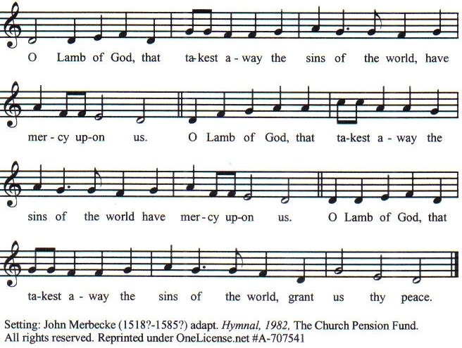
Prayer for Absolution (the people kneeling or sitting):
Minister: Almighty God, our heavenly Father, who of your great mercy has promised forgiveness of sins to all those who with hearty repentance and true faith turn unto You; Have mercy upon us; pardon and deliver us from all our sins, confirm and strengthen us in all goodness, and bring us to everlasting life, through Jesus Christ our Lord.
All: Amen.
The Comforting Words of Forgiveness (the people sitting):
Minister: Hear what comforting words our Savior Christ says to all who truly turn to him: Come to me, all you who are weary and carry heavy burdens, and I will give you rest. God so loved the world that he gave his only Son, so that everyone who believes in him will not perish but have eternal life. Hear also what St. Paul says: Christ Jesus came into the world to save sinners. Hear also what St. John says: If anyone sins, we have an Advocate with the Father, Jesus Christ the righteous: and he is the atonement for our sins.
The Passing of the Peace:
Minister: The peace of the Lord be always with you.
People: And also with you.
Minister: As the peace of Christ has been extended to you, extend the peace of the Lord to one another, and greet one another in the name of the Lord. (The people rise and remain standing.)
(The people greet those near to them, saying, “The peace of the Lord be with you,” or, “Peace be with you,” or simply, “Peace.” They respond to one another, “And also with you,” or simply, “Peace”.)
Hymn of Entry Into the Heavenly Worship (all standing):
Joyful, Joyful, We Adore Thee (No. 181)
Preparation for the Table:
(Minister: I wash my hands in innocence, and go about your altar, O LORD, proclaiming aloud your praise and telling of all your wonderful deeds). [Psalm 26:6-7, NIV]
The Sursum Corda (all standing):
Minister: The Lord be with you.
People: And also with you.
Minister: Lift up your hearts.
People: We lift them up unto the Lord.
Minister: Let us give thanks unto our Lord God.
People: It is meet and right so to do.

The Salutation:
Minister: It is very meet, right, and our gladsome duty, that we should at all times, and in all places, give thanks unto You, O Lord, Holy Father, Almighty, Everlasting God.

The Preface:
Minister: But chiefly we are bound to praise You for the glorious resurrection of your Son Jesus Christ our Lord; for he is the very Paschal Lamb, who was sacrificed for us, and he has taken away the sin of the world. By his death He has destroyed death, and by his rising to life again He has won for us everlasting life.
Minister: Therefore, with Angels and Archangels and with all the company of heaven, we laud and magnify your glorious Name, evermore praising thee, and saying,

The Sanctus (all standing and singing):
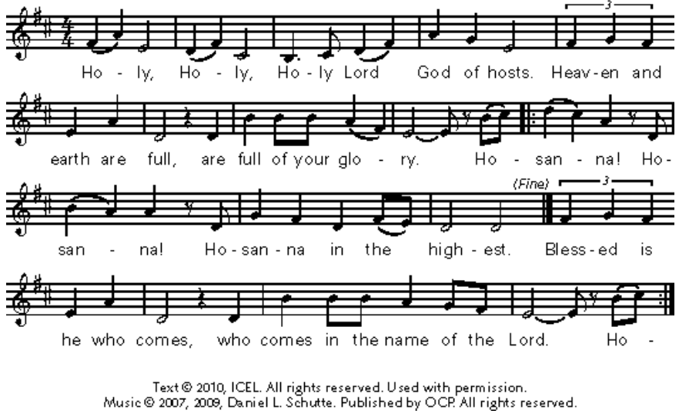

The Prayer of Humble Access and for Cleansing
(the people kneeling or sitting):
Minister: Let us pray together:
All: We do not presume to come to this your table, O merciful Lord, trusting in our own righteousness, but in your many and great mercies. We are not worthy so much as to gather up the crumbs under your table. But You are the same Lord, whose nature is always to have mercy: Grant us, therefore, gracious Lord, so to experience the spiritual presence of your dear Son Jesus Christ at this your table, that we may be made clean by his body and blood, and that we may evermore dwell in him, and he in us. Amen.

Epiclesis Prayer (the people kneeling or sitting):
Minister: Almighty God, our heavenly Father, You are holy indeed and the source of all holiness. Of your tender mercy You gave your only Son Jesus Christ to suffer death upon the cross for our redemption. He made there a full, perfect, and sufficient sacrifice for the sins of the whole world; and he instituted, and in his holy Gospel commanded us to continue, a perpetual remembrance of his precious death until his coming again. Merciful Father, we ask You to hear us, that with your Holy Spirit and Word You will now bless and sanctify these your gifts and grant that by the power of your Holy Spirit and according to your holy will, these gifts of bread and wine may be to us the Body and Blood of our Lord Jesus Christ. We ask this through Jesus Christ, your Son, our Lord; through him, and with him, and in him, in the unity of the Holy Spirit, all honor and glory are yours, O Father Almighty, now and forever.
All: Amen.
The Words of Institution (the people kneeling or sitting):
Minister: Our Lord Jesus Christ, on the night that he was betrayed took bread; and when he had given thanks, he broke it, and gave it to his disciples, saying, Take, eat; this is my Body which is given for you: do this in remembrance of me.
Likewise, after supper, he took the cup; and when he had given thanks, he gave it to them, saying, Drink this, all of you; for this is my blood of the New Testament, which is shed for you, and for many, for the remission of sins: Do this, as often as you shall drink it, in remembrance of me.
All: Amen.
Minister: Therefore, we proclaim: Alleluia! Christ is risen.
People: The Lord is risen indeed. Alleluia.
The Fraction:
Minister: Alleluia! Christ our passover is sacrificed for us.
People: Therefore let us keep the feast. Alleluia.

Fraction Anthem (the people kneeling or sitting, singing):
(The cantor sings the first line, and then all sing the other lines.)
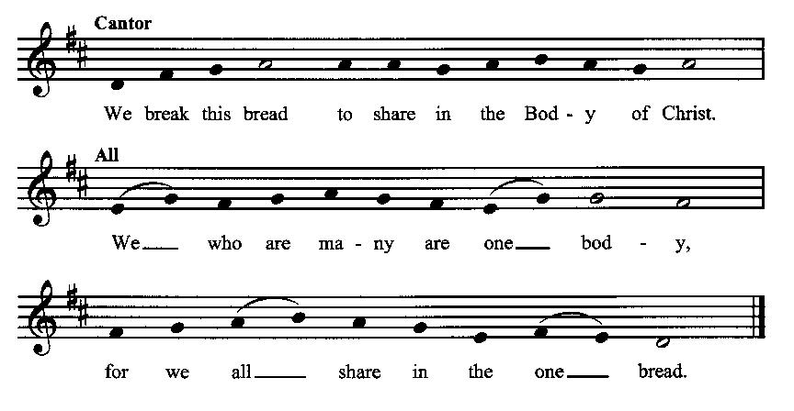

Minister: The gifts of God for the people of God. Take them in remembrance that Christ died for you, and feed on him in your hearts by faith with thanksgiving.
Communion Hymn (cantors only, the people kneeling or sitting):
“The day of resurrection! Earth, tell it out abroad; the Passover of gladness, the Passover of God. From death to life eternal, from earth unto the sky, our Christ hath brought us over, with hymns of victory.
Now let the heavens be joyful! Let earth her song begin! Let the round world keep triumph, and all that is therein! Let all things seen and unseen their notes in gladness blend, for Christ the Lord hath risen, our joy that hath no end.” (The Day of Resurrection, vv. 1, 3; Charles Wesley)
The Communion, open to all: (After the minister(s) and acolyte(s) are served, the people come forward to receive, as space is available. The people kneel if they are able, or STAND in accord with the practice of the ancient church during Easter, symbolic of being raised up with Christ in his victory. Communion by intincture: The people receive the Bread in their open hands, continue to hold it, then dip the Bread in the cup, and then consume.) They return to their seats via the side aisles.
Renewal of the Mutual Invocation of God’s Grace for the Eucharist:
Minister: The Lord be with you.
People: And also with you.
The Prayer of Thanksgiving and Living Sacrifice:
(The minister kneeling, the people kneeling or sitting):

Minister: Let us pray together:
All: O Lord and Heavenly Father, we heartily thank You because You feed us, in these holy mysteries, with the spiritual food of the most precious Body and Blood of your Son our Savior Jesus Christ; because by this You assure us of your favor and goodness toward us; because we are living members of the body of your Son and heirs of your eternal kingdom. We ask You to accept this our sacrifice of praise and thanksgiving, and to grant that by the merits and death of your Son Jesus Christ and through faith in him, we and all your whole Church may obtain all of the benefits of his passion. And here we offer and present unto You, O Lord, ourselves, our souls and bodies, to be a reasonable, holy, and living sacrifice unto You; humbly asking You that we may be filled with your grace and heavenly benediction; through Jesus Christ our Lord; by whom, and with whom, in the Unity of the Holy Spirit, all honor and glory be unto You, O Father Almighty, world without end. AMEN.
The Gloria Prayer of Praise and Thanksgiving (all standing):
Minister: Let us pray together:
All: Glory be to God on high, and on earth peace, good-will toward all people. We praise You, we bless You, we worship You, we glorify You, we give thanks to You for your great glory, O Lord God, heavenly King, God the Father Almighty. For You only are the Holy One, You only are the Lord, You only, O Christ, with the Holy Spirit, are most high in the glory of God the Father. Amen.

ACTS OF DISMISSAL

Recessional Hymn (all standing):
Christ, the Lord, Is Risen Today (No. 172)
The Prayer of Benediction:
Minister: May the peace of God, which passes all understanding, keep your hearts and minds in the knowledge and love of God, and of his Son Jesus Christ our Lord; and may the blessing of God Almighty, the Father, the Son, and the Holy Spirit, be among you, and remain with you always.
All: Amen.
Minister: Let us go forth in the name of Christ.
People: Thanks be to God. Alleluia. Alleluia.
(The people then be seated.)
Greetings and Announcements
Postlude:
____________________________
Based on, and freely adapted from,
John Wesley’s Order for the Administration of the Lord’s Supper,
The 1662 and 1979 editions of The Book of Common Prayer, and
Common Worship: Services and Prayers for the Church of England
__________________________________

Scripture lessons for April 7 (Easter 2):
Acts 3:12-26; Psalm 118:19-24; I John 5:1-6; John 20:19-31

Parish Prayer for This Week and Next Sunday
Those living on Fisk Lane
___________________________

An Easter Prayer
O Lord Jesus Christ, who on the evening of the first Easter Day appeared to your disciples when they were afraid and spoke to them your word of peace: Grant to us your servants that same holy peace, that we may walk henceforth in the light of your presence and know the power of your risen life, until we come to the joy of your everlasting kingdom. Amen.

Parish Notices

Ending Today: March to End Hunger Food Drive
Today is the last day to collect food for the annual Boise Rescue Mission March to End Hunger food drive.

Coming Events at Epworth

Today, 10:00 am Word & Table Service
Today, 11:30 am Fellowship
Today, 11:40 am Afterword (moderated discussion)
Sunday, 14 April A-Team (9 am)

April Birthdays & Anniversaries

02 – Robyn Millar
05 – Jessica Crosswhite
16 – Dorothy Millard

Sermon Notes

Epworth Church Office Email
epworthchapel.office@gmail.com
All correspondence for the office should be sent to this email address.

Pastor Crow Contact Information
Healing prayer is provided every week upon request
Rev. John Crow, Interim Rector and Pastor
208-501-4037
jdowningcrow@hotmail.com

